Reference Link: <https://www.examtopics.com/exams/microsoft/ai-102/view/>

<https://www.itexams.com/exam/AI-102>

<file:///C:/Users/DenilaRajendran/Downloads/AI-102-demo.pdf>

<file:///C:/Users/DenilaRajendran/Downloads/AI-102-demo%20(1).pdf>

**Q1: DRAG DROP -  
You have 100 chatbots that each has its own Language Understanding model.  
Frequently, you must add the same phrases to each model.  
You need to programmatically update the Language Understanding models to include the new phrases.  
How should you complete the code? To answer, drag the appropriate values to the correct targets. Each value may be used once, more than once, or not at all.  
You may need to drag the split bar between panes or scroll to view content.  
NOTE: Each correct selection is worth one point.  
Select and Place:**

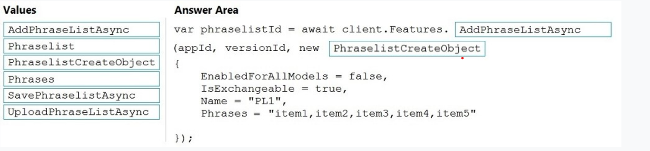

Box 1: AddPhraseListAsync -  
  
Example: Add phraselist feature -  
var phraselistId = await client.Features.AddPhraseListAsync(appId, versionId, new PhraselistCreateObject  
{  
EnabledForAllModels = false,  
IsExchangeable = true,  
Name = "QuantityPhraselist",  
Phrases = "few,more,extra"  
});  
  
Box 2: PhraselistCreateObject -  
Reference:  
https://docs.microsoft.com/en-us/azure/cognitive-services/luis/client-libraries-rest-api

**Q2: DRAG DROP -  
You plan to use a Language Understanding application named app1 that is deployed to a container.  
App1 was developed by using a Language Understanding authoring resource named lu1.  
App1 has the versions shown in the following table.  
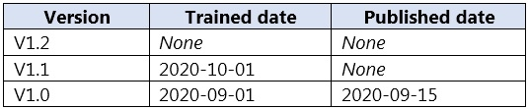  
You need to create a container that uses the latest deployable version of app1.  
Which three actions should you perform in sequence? To answer, move the appropriate actions from the list of actions to the answer area and arrange them in the correct order.  
Select and Place:**

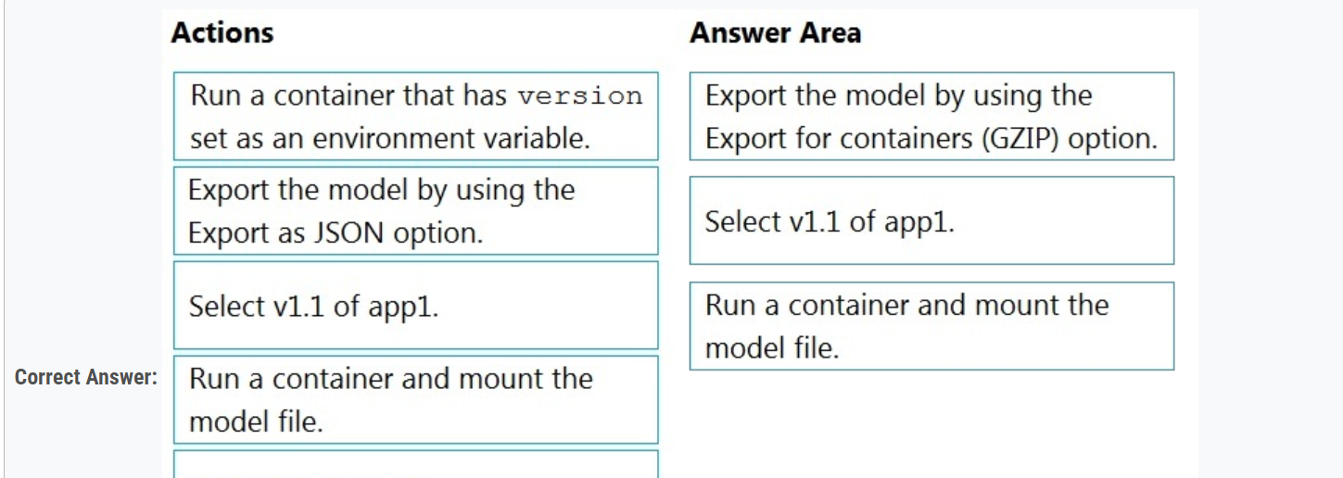

Step 1: Export the model using the Export for containers (GZIP) option.  
Export versioned app's package from LUIS portal  
The versioned app's package is available from the Versions list page.  
1. Sign on to the LUIS portal.  
2. Select the app in the list.  
3. Select Manage in the app's navigation bar.  
4. Select Versions in the left navigation bar.  
5. Select the checkbox to the left of the version name in the list.  
6. Select the Export item from the contextual toolbar above the list.  
7. Select Export for container (GZIP).  
8. The package is downloaded from the browser.  
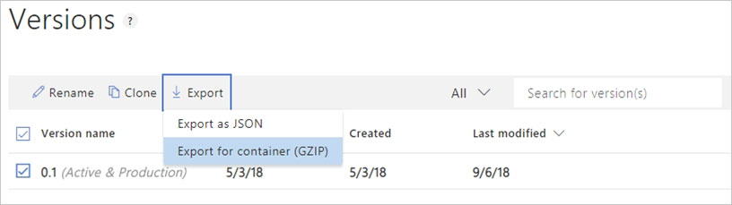  
Step 2: Select v1.1 of app1.  
A trained or published app packaged as a mounted input to the container with its associated App ID.  
Step 3: Run a contain and mount the model file.  
Run the container, with the required input mount and billing settings.  
Reference:  
<https://docs.microsoft.com/en-us/azure/cognitive-services/luis/luis-container-howto>

**Q3: You need to build a chatbot that meets the following requirements:  
✑ Supports chit-chat, knowledge base, and multilingual models  
✑ Performs sentiment analysis on user messages  
✑ Selects the best language model automatically  
What should you integrate into the chatbot?**

* **A. QnA Maker, Language Understanding, and Dispatch**
* **B. Translator, Speech, and Dispatch**
* **C. Language Understanding, Text Analytics, and QnA Maker**
* **D. Text Analytics, Translator, and Dispatch**

Language Understanding: An AI service that allows users to interact with your applications, bots, and IoT devices by using natural language.  
QnA Maker is a cloud-based Natural Language Processing (NLP) service that allows you to create a natural conversational layer over your data. It is used to find the most appropriate answer for any input from your custom knowledge base (KB) of information.  
Text Analytics: Mine insights in unstructured text using natural language processing (NLP)ג€"no machine learning expertise required. Gain a deeper understanding of customer opinions with sentiment analysis. The Language Detection feature of the Azure Text Analytics REST API evaluates text input  
Incorrect Answers:  
A, B, D: Dispatch uses sample utterances for each of your bot's different tasks (LUIS, QnA Maker, or custom), and builds a model that can be used to properly route your user's request to the right task, even across multiple bots.  
Reference:  
https://azure.microsoft.com/en-us/services/cognitive-services/text-analytics/ https://docs.microsoft.com/en-us/azure/cognitive-services/qnamaker/overview/overview

Q4: **company wants to reduce how long it takes for employees to log receipts in expense reports. All the receipts are in English.  
You need to extract top-level information from the receipts, such as the vendor and the transaction total. The solution must minimize development effort.  
Which Azure service should you use?**

* **A. Custom Vision**
* **B. Personalizer**
* **C. Form Recognizer Most Voted**
* **D. Computer Vision**

Azure Form Recognizer is a cognitive service that lets you build automated data processing software using machine learning technology. Identify and extract text, key/value pairs, selection marks, tables, and structure from your documentsג€"the service outputs structured data that includes the relationships in the original file, bounding boxes, confidence and more.  
Form Recognizer is composed of custom document processing models, prebuilt models for invoices, receipts, IDs and business cards, and the layout model.  
Reference:  
<https://docs.microsoft.com/en-us/azure/cognitive-services/form-recognizer>

**Q5: HOTSPOT -  
You need to create a new resource that will be used to perform sentiment analysis and optical character recognition (OCR). The solution must meet the following requirements:  
✑ Use a single key and endpoint to access multiple services.  
✑ Consolidate billing for future services that you might use.  
✑ Support the use of Computer Vision in the future.  
How should you complete the HTTP request to create the new resource? To answer, select the appropriate options in the answer area.  
NOTE: Each correct selection is worth one point.  
Hot Area**:

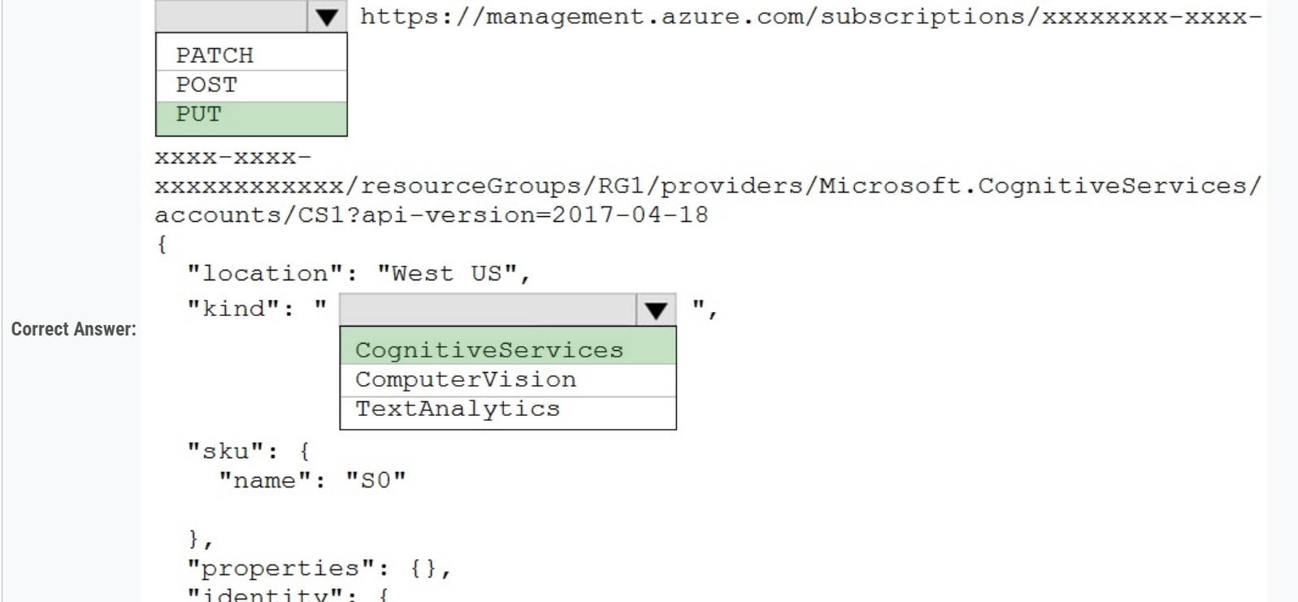

Box 1: PUT -  
Sample Request: PUT https://management.azure.com/subscriptions/00000000-0000-0000-0000-000000000000/resourceGroups/test-rg/providers/  
Microsoft.DeviceUpdate/accounts/contoso?api-version=2020-03-01-preview  
Incorrect Answers:  
PATCH is for updates.  
  
Box 2: CognitiveServices -  
Microsoft Azure Cognitive Services provide us to use its pre-trained models for various Business Problems related to Machine Learning.  
List of Different Services are:  
✑ Decision  
✑ Language (includes sentiment analysis)  
✑ Speech  
✑ Vision (includes OCR)  
✑ Web Search  
Reference:  
https://docs.microsoft.com/en-us/rest/api/deviceupdate/resourcemanager/accounts/create <https://www.analyticsvidhya.com/blog/2020/12/microsoft-azure-cognitive-services-api-for-ai-development/\>

**Q6: You are developing a new sales system that will process the video and text from a public-facing website.  
You plan to monitor the sales system to ensure that it provides equitable results regardless of the user's location or background.  
Which two responsible AI principles provide guidance to meet the monitoring requirements? Each correct answer presents part of the solution.  
NOTE: Each correct selection is worth one point.**

* **A. transparency**
* **B. fairness**
* **C. inclusiveness**
* **D. reliability and safety**
* **E. privacy and security**

AI systems should treat all people fairly.  
AI systems should perform reliably and safely.  
Reference:  
<https://docs.microsoft.com/en-us/azure/cloud-adoption-framework/strategy/responsible-ai>

**Q7: DRAG DROP -  
You plan to use containerized versions of the Anomaly Detector API on local devices for testing and in on-premises datacenters.  
You need to ensure that the containerized deployments meet the following requirements:  
✑ Prevent billing and API information from being stored in the command-line histories of the devices that run the container.  
✑ Control access to the container images by using Azure role-based access control (Azure RBAC).  
Which four actions should you perform in sequence? To answer, move the appropriate actions from the list of actions to the answer area and arrange them in the correct order.  
NOTE: More than one order of answer choices is correct. You will receive credit for any of the correct orders you select.  
Select and Place:**

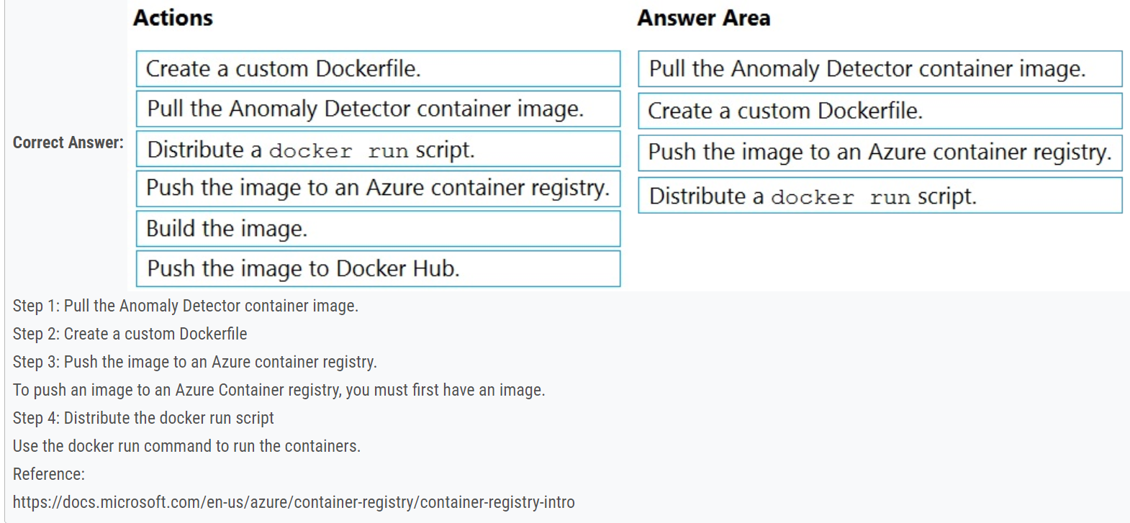

**Q8: HOTSPOT -  
You plan to deploy a containerized version of an Azure Cognitive Services service that will be used for text analysis.**  
**You configure https://contoso.cognitiveservices.azure.com as the endpoint URI for the service, and you pull the latest version of the Text Analytics  
Sentiment Analysis container.  
You need to run the container on an Azure virtual machine by using Docker.  
How should you complete the command? To answer, select the appropriate options in the answer area.  
NOTE: Each correct selection is worth one point.  
Hot Area:**

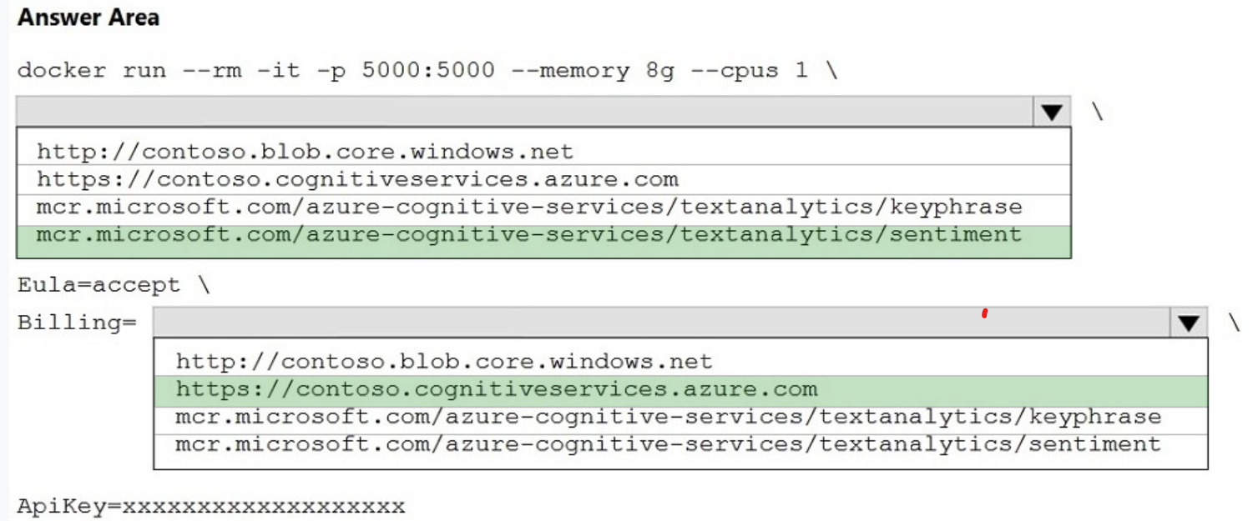

Box 1: mcr.microsoft.com/azure-cognitive-services/textanalytics/sentiment  
To run the Sentiment Analysis v3 container, execute the following docker run command. docker run --rm -it -p 5000:5000 --memory 8g --cpus 1 \ mcr.microsoft.com/azure-cognitive-services/textanalytics/sentiment \  
Eula=accept \  
Eula=accept \  
Billing={ENDPOINT_URI} \  
ApiKey={API_KEY} is the endpoint for accessing the Text Analytics API. https://<your-custom-subdomain>.cognitiveservices.azure.com  
Box 2: https://contoso.cognitiveservices.azure.com  
{ENDPOINT_URI} is the endpoint for accessing the Text Analytics API: https://<your-custom-subdomain>.cognitiveservices.a The endpoint for accessing the Text  
  
Analytics API. zure.com -  
Reference:  
https://docs.microsoft.com/en-us/azure/cognitive-services/text-analytics/how-tos/text-analytics-how-to-install-containers?tabs=sentiment

Question #9

**You have the following C# method for creating Azure Cognitive Services resources programmatically.**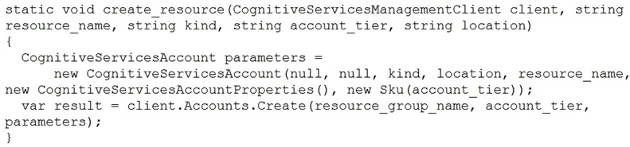  
You need to call the method to create a free Azure resource in the West US Azure region. The resource will be used to generate captions of images automatically.  
Which code should you use?

* A. create_resource(client, "res1", "ComputerVision", "F0", "westus")
* B. create_resource(client, "res1", "CustomVision.Prediction", "F0", "westus")
* C. create_resource(client, "res1", "ComputerVision", "S0", "westus")
* D. create_resource(client, "res1", "CustomVision.Prediction", "S0", "westus")

Many of the Cognitive Services have a free tier you can use to try the service. To use the free tier, use F0 as the SKU for your resource.  
There are two tiers of keys for the Custom Vision service. You can sign up for a F0 (free) or S0 (standard) subscription through the Azure portal.  
Incorrect Answers:  
A: There is no free tier (F0) for ComputerVision.  
Reference:  
https://docs.microsoft.com/en-us/azure/cognitive-services/cognitive-services-apis-create-account-client-library?pivots=programming-language-csharp <https://docs.microsoft.com/en-us/azure/cognitive-services/custom-vision-service/limits-and-quotas>

Question #10*Topic 1*

You successfully run the following HTTP request.  
POST **https://management.azure.com/subscriptions/18c51a87-3a69-47a8-aedc-a54745f708a1/resourceGroups/RG1/providers/  
Microsoft.CognitiveServices/accounts/contoso1/regenerateKey?api-version=2017-04-18  
Body{"keyName": "Key2"}**  
What is the result of the request?

* A. A key for Azure Cognitive Services was generated in Azure Key Vault.
* B. A new query key was generated.
* C. The primary subscription key and the secondary subscription key were rotated.
* D. The secondary subscription key was reset.

Accounts - Regenerate Key regenerates the specified account key for the specified Cognitive Services account.  
Syntax:  
POST https://management.azure.com/subscriptions/{subscriptionId}/resourceGroups/{resourceGroupName}/providers/Microsoft.CognitiveServices/accounts/  
{accountName}/regenerateKey?api-version=2017-04-18  
Reference:  
<https://docs.microsoft.com/en-us/rest/api/cognitiveservices/accountmanagement/accounts/regeneratekey>

Question #11*Topic 1*

You build a custom Form Recognizer model.  
You receive sample files to use for training the model as shown in the following table.  
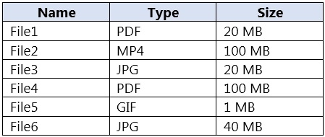  
Which three files can you use to train the model? Each correct answer presents a complete solution.  
NOTE: Each correct selection is worth one point.

* A. File1
* B. File2
* C. File3
* D. File4
* E. File5
* F. File6
* **Correct Answer:** *ACF* [🗳️](https://www.examtopics.com/exams/microsoft/ai-102/view/3/)  
  Input requirements -  
  Form Recognizer works on input documents that meet these requirements:  
  Format must be JPG, PNG, PDF (text or scanned), or TIFF. Text-embedded PDFs are best because there's no possibility of error in character extraction and location.  
  File size must be less than 50 MB.  
  Reference:  
  <https://docs.microsoft.com/en-us/azure/cognitive-services/form-recognizer/overview>

Question #12*Topic 1*

A customer uses Azure Cognitive Search.  
The customer plans to enable a server-side encryption and use customer-managed keys (CMK) stored in Azure.  
What are three implications of the planned change? Each correct answer presents a complete solution.  
NOTE: Each correct selection is worth one point.

* A. The index size will increase.
* B. Query times will increase.
* C. A self-signed X.509 certificate is required.
* D. The index size will decrease.
* E. Query times will decrease.
* F. Azure Key Vault is required

**Correct Answer:** *ABE* [🗳️](https://www.examtopics.com/exams/microsoft/ai-102/view/3/)  
Reference:  
<https://docs.microsoft.com/en-us/azure/search/search-security-overview>

Question #13*Topic 1*

You are developing a new sales system that will process the video and text from a public-facing website.  
You plan to notify users that their data has been processed by the sales system.  
Which responsible AI principle does this help meet?

* A. transparency
* B. fairness
* C. inclusiveness
* D. reliability and safety

**Correct Answer:** *D* [🗳️](https://www.examtopics.com/exams/microsoft/ai-102/view/3/)  
Reference:  
https://docs.microsoft.com/en-us/azure/cloud-adoption-framework/strategy/responsible-ai

Question #14*Topic 1*

Note: This question is part of a series of questions that present the same scenario. Each question in the series contains a unique solution that might meet the stated goals. Some question sets might have more than one correct solution, while others might not have a correct solution.  
After you answer a question in this section, you will NOT be able to return to it. As a result, these questions will not appear in the review screen.  
You create a web app named app1 that runs on an Azure virtual machine named vm1. Vm1 is on an Azure virtual network named vnet1.  
You plan to create a new Azure Cognitive Search service named service1.  
You need to ensure that app1 can connect directly to service1 without routing traffic over the public internet.  
Solution: You deploy service1 and a public endpoint to a new virtual network, and you configure Azure Private Link.  
Does this meet the goal?

* A. Yes
* B. No
* **Correct Answer:** *B* [🗳️](https://www.examtopics.com/exams/microsoft/ai-102/view/3/)  
  The Azure Private Link should use a private endpoint, not a public endpoint.  
  Private Link service can be accessed from approved private endpoints in any public region.  
  Reference:  
  https://docs.microsoft.com/en-us/azure/private-link/private-link-overview
* *Community vote distribution*

Question #15*Topic 1*

Note: This question is part of a series of questions that present the same scenario. Each question in the series contains a unique solution that might meet the stated goals. Some question sets might have more than one correct solution, while others might not have a correct solution.  
After you answer a question in this section, you will NOT be able to return to it. As a result, these questions will not appear in the review screen.  
You create a web app named app1 that runs on an Azure virtual machine named vm1. Vm1 is on an Azure virtual network named vnet1.  
You plan to create a new Azure Cognitive Search service named service1.  
You need to ensure that app1 can connect directly to service1 without routing traffic over the public internet.  
Solution: You deploy service1 and a public endpoint, and you configure an IP firewall rule.  
Does this meet the goal?

* A. Yes
* B. No

**Correct Answer:** *B* [🗳️](https://www.examtopics.com/exams/microsoft/ai-102/view/3/)  
Instead deploy service1 and a private (not public) endpoint to a new virtual network, and you configure Azure Private Link.  
Reference:  
<https://docs.microsoft.com/en-us/azure/private-link/private-link-overview>

Question #16*Topic 1*

Note: This question is part of a series of questions that present the same scenario. Each question in the series contains a unique solution that might meet the stated goals. Some question sets might have more than one correct solution, while others might not have a correct solution.  
After you answer a question in this section, you will NOT be able to return to it. As a result, these questions will not appear in the review screen.  
You create a web app named app1 that runs on an Azure virtual machine named vm1. Vm1 is on an Azure virtual network named vnet1.  
You plan to create a new Azure Cognitive Search service named service1.  
You need to ensure that app1 can connect directly to service1 without routing traffic over the public internet.  
Solution: You deploy service1 and a public endpoint, and you configure a network security group (NSG) for vnet1.  
Does this meet the goal?

* A. Yes
* B. No

**Correct Answer:** *B* [🗳️](https://www.examtopics.com/exams/microsoft/ai-102/view/4/)  
Instead deploy service1 and a private (not public) endpoint to a new virtual network, and you configure Azure Private Link.  
Reference:  
https://docs.microsoft.com/en-us/azure/private-link/private-link-overview

Question #17*Topic 1*

You plan to perform predictive maintenance.  
You collect IoT sensor data from 100 industrial machines for a year. Each machine has 50 different sensors that generate data at one-minute intervals. In total, you have 5,000 time series datasets.  
You need to identify unusual values in each time series to help predict machinery failures.  
Which Azure service should you use?

* A. Anomaly Detector
* B. Cognitive Search
* C. Form Recognizer
* D. Custom Vision
* Question #18*Topic 1*
* HOTSPOT -  
  You are developing a streaming Speech to Text solution that will use the Speech SDK and MP3 encoding.  
  You need to develop a method to convert speech to text for streaming MP3 data.  
  How should you complete the code? To answer, select the appropriate options in the answer area.  
  NOTE: Each correct selection is worth one point.  
  Hot Area:

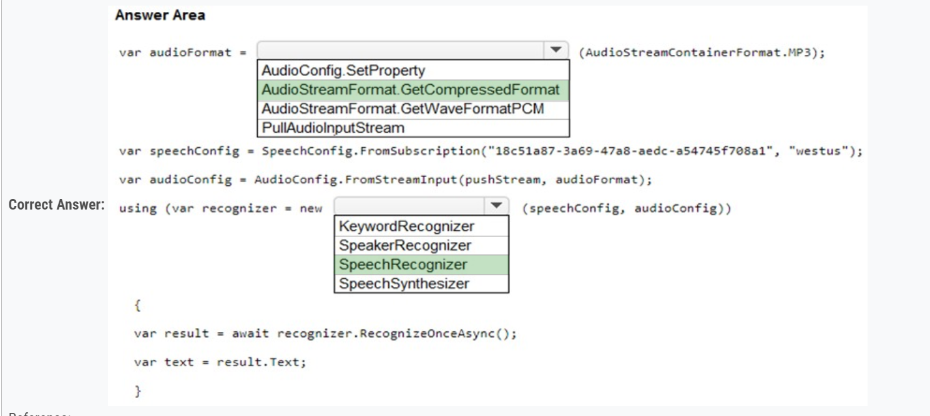

Question #19*Topic 1*

HOTSPOT -  
You are developing an internet-based training solution for remote learners.  
Your company identifies that during the training, some learners leave their desk for long periods or become distracted.  
You need to use a video and audio feed from each learner's computer to detect whether the learner is present and paying attention. The solution must minimize development effort and identify each learner.  
Which Azure Cognitive Services service should you use for each requirement? To answer, select the appropriate options in the answer area.  
NOTE: Each correct selection is worth one point.  
Hot Area:

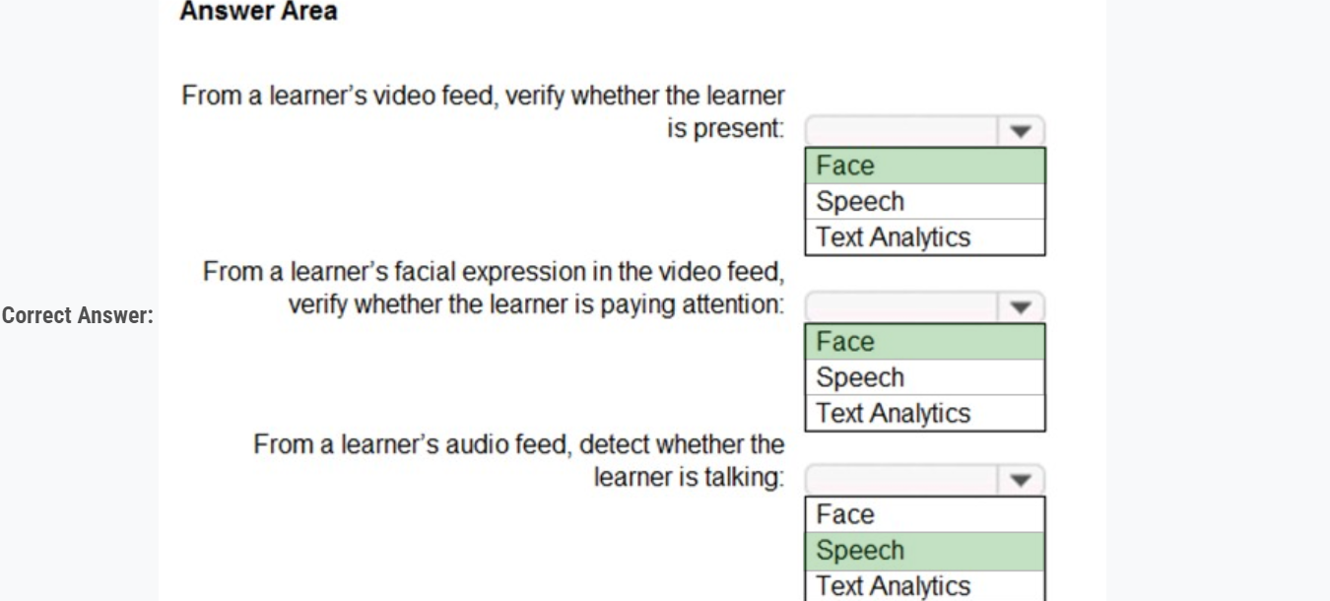

Question #20*Topic 1*

You plan to provision a QnA Maker service in a new resource group named RG1.  
In RG1, you create an App Service plan named AP1.  
Which two Azure resources are automatically created in RG1 when you provision the QnA Maker service? Each correct answer presents part of the solution.  
NOTE: Each correct selection is worth one point.

* A. Language Understanding
* B. Azure SQL Database
* C. Azure Storage
* D. Azure Cognitive Search
* E. Azure App Service

Question #21*Topic 1*

You are building a language model by using a Language Understanding (classic) service.  
You create a new Language Understanding (classic) resource.  
You need to add more contributors.  
What should you use?

* A. a conditional access policy in Azure Active Directory (Azure AD)
* B. the Access control (IAM) page for the authoring resources in the Azure portal
* C. the Access control (IAM) page for the prediction resources in the Azure portal

Question #22*Topic 1*

Note: This question is part of a series of questions that present the same scenario. Each question in the series contains a unique solution that might meet the stated goals. Some question sets might have more than one correct solution, while others might not have a correct solution.  
After you answer a question in this section, you will NOT be able to return to it. As a result, these questions will not appear in the review screen.  
**You have an Azure Cognitive Search service.  
During the past 12 months, query volume steadily increased.  
You discover that some search query requests to the Cognitive Search service are being throttled.  
You need to reduce the likelihood that search query requests are throttled.  
Solution: You migrate to a Cognitive Search service that uses a higher tier.  
Does this meet the goal?**

* A. Yes
* B. No

**Correct Answer:** *A* [🗳️](https://www.examtopics.com/exams/microsoft/ai-102/view/5/)  
A simple fix to most throttling issues is to throw more resources at the search service (typically replicas for query-based throttling, or partitions for indexing-based throttling). However, increasing replicas or partitions adds cost, which is why it is important to know the reason why throttling is occurring at all.  
Reference:  
<https://docs.microsoft.com/en-us/azure/search/search-performance-analysis\>

Question #23*Topic 1*

DRAG DROP -  
You need to develop an automated call handling system that can respond to callers in their own language. The system will support only French and English.  
Which Azure Cognitive Services service should you use to meet each requirement? To answer, drag the appropriate services to the correct requirements. Each service may be used once, more than once, or not at all. You may need to drag the split bat between panes or scroll to view content.  
NOTE: Each correct selection is worth one point.  
Select and Place:

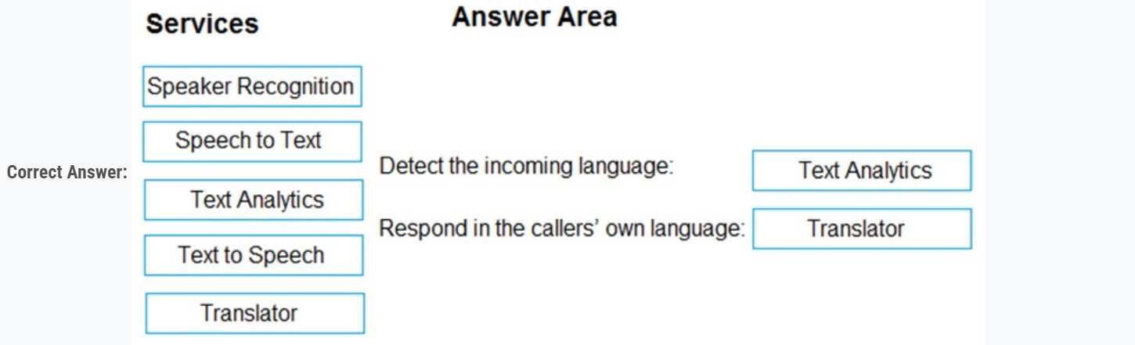

Box 1: Text Analytics -  
The Language Detection feature of the Azure Text Analytics REST API evaluates text input for each document and returns language identifiers with a score that indicates the strength of the analysis.  
Incorrect Answers:  
Speaker Recognition which accurately verifies and identifies speakers by their unique voice characteristics.  
  
Box 2: Translator -  
Translator is a cloud-based neural machine translation service that is part of the Azure Cognitive Services family of REST APIs. Translator can be used with any operating system and powers many Microsoft products and services used by thousands of businesses worldwide to perform language translation and other language-related operations.  
Reference:  
https://docs.microsoft.com/en-us/azure/cognitive-services/text-analytics/how-tos/text-analytics-how-to-language-detection <https://docs.microsoft.com/en-us/azure/cognitive-services/translator/translator-overview>

Question #24*Topic 1*

You have receipts that are accessible from a URL.  
You need to extract data from the receipts by using Form Recognizer and the SDK. The solution must use a prebuilt model.  
Which client and method should you use?

* A. the FormRecognizerClient client and the StartRecognizeContentFromUri method
* B. the FormTrainingClient client and the StartRecognizeContentFromUri method
* C. the FormRecognizerClient client and the StartRecognizeReceiptsFromUri method **Most Voted**
* D. the FormTrainingClient client and the StartRecognizeReceiptsFromUri metho

**Correct Answer:** *D* [🗳️](https://www.examtopics.com/exams/microsoft/ai-102/view/5/)  
To analyze receipts from a URL, use the StartRecognizeReceiptsFromUri method  
Example code:  
private static async Task AnalyzeReceipt(  
FormRecognizerClient recognizerClient, string receiptUri)  
{  
RecognizedFormCollection receipts = await recognizerClient.StartRecognizeReceiptsFromUri(new Uri(receiptUrl)).WaitForCompletionAsync();  
Reference:  
https://docs.microsoft.com/en-us/azure/applied-ai-services/form-recognizer/quickstarts/client-library

Question #25*Topic 1*

You have a collection of 50,000 scanned documents that contain text.  
You plan to make the text available through Azure Cognitive Search.  
You need to configure an enrichment pipeline to perform optical character recognition (OCR) and text analytics. The solution must minimize costs.  
What should you attach to the skillset?

* A. a new Computer Vision resource
* B. a free (Limited enrichments) Cognitive Services resource
* C. an Azure Machine Learning Designer pipeline
* D. a new Cognitive Services resource that uses the S0 pricing tier

**Correct Answer:** *A* [🗳️](https://www.examtopics.com/exams/microsoft/ai-102/view/5/)  
The Computer Vision API uses text recognition APIs to extract and recognize text information from images. Read uses the latest recognition models, and is optimized for large, text-heavy documents and noisy images.  
Reference:  
https://docs.microsoft.com/en-us/azure/architecture/solution-ideas/articles/cognitive-search-with-skillsets

Question #26*Topic 1*

Note: This question is part of a series of questions that present the same scenario. Each question in the series contains a unique solution that might meet the stated goals. Some question sets might have more than one correct solution, while others might not have a correct solution.  
After you answer a question in this section, you will NOT be able to return to it. As a result, these questions will not appear in the review screen.  
You have an Azure Cognitive Search service.  
During the past 12 months, query volume steadily increased.  
You discover that some search query requests to the Cognitive Search service are being throttled.  
You need to reduce the likelihood that search query requests are throttled.  
Solution: You add indexes.  
Does this meet the goal?

* A. Yes
* B. No

**Correct Answer:** *B* [🗳️](https://www.examtopics.com/exams/microsoft/ai-102/view/6/)  
Instead, you could migrate to a Cognitive Search service that uses a higher tier.  
Note: A simple fix to most throttling issues is to throw more resources at the search service (typically replicas for query-based throttling, or partitions for indexing- based throttling). However, increasing replicas or partitions adds cost, which is why it is important to know the reason why throttling is occurring at all.  
Reference:  
<https://docs.microsoft.com/en-us/azure/search/search-performance-analysis>

Question #27*Topic 1*

Note: This question is part of a series of questions that present the same scenario. Each question in the series contains a unique solution that might meet the stated goals. Some question sets might have more than one correct solution, while others might not have a correct solution.  
After you answer a question in this section, you will NOT be able to return to it. As a result, these questions will not appear in the review screen.  
**You have an Azure Cognitive Search service.  
During the past 12 months, query volume steadily increased.  
You discover that some search query requests to the Cognitive Search service are being throttled.  
You need to reduce the likelihood that search query requests are throttled.  
Solution: You enable customer-managed key (CMK) encryption.  
Does this meet the goal?**

* A. Yes
* B. No

**Correct Answer:** *B* [🗳️](https://www.examtopics.com/exams/microsoft/ai-102/view/6/)  
Customer-managed key (CMK) encryption does not affect throttling.  
Instead, you could migrate to a Cognitive Search service that uses a higher tier.  
Note: A simple fix to most throttling issues is to throw more resources at the search service (typically replicas for query-based throttling, or partitions for indexing- based throttling). However, increasing replicas or partitions adds cost, which is why it is important to know the reason why throttling is occurring at all.  
Reference:  
<https://docs.microsoft.com/en-us/azure/search/search-performance-analysis>

Question #28*Topic 1*

Note: This question is part of a series of questions that present the same scenario. Each question in the series contains a unique solution that might meet the stated goals. Some question sets might have more than one correct solution, while others might not have a correct solution.  
After you answer a question in this section, you will NOT be able to return to it. As a result, these questions will not appear in the review screen.  
**You create a web app named app1 that runs on an Azure virtual machine named vm1. Vm1 is on an Azure virtual network named vnet1.  
You plan to create a new Azure Cognitive Search service named service1.  
You need to ensure that app1 can connect directly to service1 without routing traffic over the public internet**.  
Solution: You deploy service1 and a private endpoint to vnet1.  
Does this meet the goal?

* A. Yes
* B. No

**Correct Answer:** *A* [🗳️](https://www.examtopics.com/exams/microsoft/ai-102/view/6/)  
A private endpoint is a network interface that uses a private IP address from your virtual network. This network interface connects you privately and securely to a service powered by Azure Private Link. By enabling a private endpoint, you're bringing the service into your virtual network.  
The service could be an Azure service such as:  
✑ Azure Storage  
✑ Azure Cosmos DB  
✑ Azure SQL Database  
✑ Your own service using a Private Link Service.  
Reference:  
<https://docs.microsoft.com/en-us/azure/private-link/private-endpoint-overview>

Question #29*Topic 1*

You have a Language Understanding resource named lu1.  
You build and deploy an Azure bot named bot1 that uses lu1.  
You need to ensure that bot1 adheres to the Microsoft responsible AI principle of inclusiveness.  
How should you extend bot1?

* A. Implement authentication for bot1.
* B. Enable active learning for lu1.
* C. Host lu1 in a container.
* D. Add Direct Line Speech to bot1.

**Correct Answer:** *D* [🗳️](https://www.examtopics.com/exams/microsoft/ai-102/view/6/)  
Inclusiveness: AI systems should empower everyone and engage people.  
Direct Line Speech is a robust, end-to-end solution for creating a flexible, extensible voice assistant. It is powered by the Bot Framework and its Direct Line  
Speech channel, that is optimized for voice-in, voice-out interaction with bots.  
Incorrect:  
Not B: The Active learning suggestions feature allows you to improve the quality of your knowledge base by suggesting alternative questions, based on user- submissions, to your question and answer pair. You review those suggestions, either adding them to existing questions or rejecting them.  
Reference:  
<https://docs.microsoft.com/en-us/azure/cognitive-services/speech-service/direct-line-speech>

Question #30*Topic 1*

HOTSPOT -  
You are building an app that will process incoming email and direct messages to either French or English language support teams.  
Which Azure Cognitive Services API should you use? To answer, select the appropriate options in the answer area.  
NOTE: Each correct selection is worth one point.  
Hot Area:

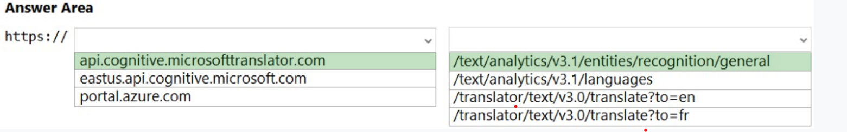

Box 1: api/cognitive.microsofttranslator.com is used for translations.  
Incorrect:  
eastus.api.cognitive.microsoft.com is used for Face recognition.  
Portal.azure.com is the URL of the Azure portal which is a web-based, unified console that provides an alternative to command-line tools. With the Azure portal, you can manage your Azure subscription using a graphical user interface. You can build, manage, and monitor everything from simple web apps to complex cloud deployments.  
Box 2: /text/analytics/v3.1/entities/recognition/general  
Named Entity Recognition -  
The API returns a list of general named entities in a given document.  
Request URL: https://{endpoint}/text/analytics/v3.1/entities/recognition/general[?model-version][&showStats][&loggingOptOut][&stringIndexType]  
Reference:  
https://docs.microsoft.com/en-us/azure/cognitive-services/translator/reference/v3-0-translate <https://westcentralus.dev.cognitive.microsoft.com/docs/services/TextAnalytics-v3-1/operations/EntitiesRecognitionGeneral>

Question #31*Topic 1*

You have an Azure Cognitive Search instance that indexes purchase orders by using Form Recognizer.  
You need to analyze the extracted information by using Microsoft Power BI. The solution must minimize development effort.  
What should you add to the indexer?

* A. a projection group
* B. a table projection
* C. a file projection
* D. an object projection

**Correct Answer:** *D* [🗳️](https://www.examtopics.com/exams/microsoft/ai-102/view/7/)  
Projections are the physical tables, objects, and files in a knowledge store that accept content from a Cognitive Search AI enrichment pipeline. If you're creating a knowledge store, defining and shaping projections is most of the work.  
Objects is used when you need the full JSON representation of your data and enrichments in one JSON document. As with table projections, only valid JSON objects can be projected as objects, and shaping can help you do that.  
Note: Form Recognizer analyzes your forms and documents, extracts text and data, maps field relationships as key-value pairs, and returns a structured JSON output. You quickly get accurate results that are tailored to your specific content without excessive manual intervention or extensive data science expertise.  
Incorrect:  
Not Tables: Tables is used for data that's best represented as rows and columns, or whenever you need granular representations of your data (for example, as data frames). Table projections allow you to define a schematized shape, using a Shaper skill or use inline shaping to specify columns and rows.  
Not File: File is used when you need to save normalized, binary image files.  
Reference:  
<https://docs.microsoft.com/en-us/azure/search/knowledge-store-projection-overview>

Question #32*Topic 1*

Note: This question is part of a series of questions that present the same scenario. Each question in the series contains a unique solution that might meet the stated goals. Some question sets might have more than one correct solution, while others might not have a correct solution.  
After you answer a question in this section, you will NOT be able to return to it. As a result, these questions will not appear in the review screen.  
**You have an Azure Cognitive Search service.  
During the past 12 months, query volume steadily increased.  
You discover that some search query requests to the Cognitive Search service are being throttled.  
You need to reduce the likelihood that search query requests are throttled.  
Solution: You add replicas.  
Does this meet the goal?**

* A. Yes
* B. No

**Correct Answer:** *A* [🗳️](https://www.examtopics.com/exams/microsoft/ai-102/view/7/)  
A simple fix to most throttling issues is to throw more resources at the search service (typically replicas for query-based throttling, or partitions for indexing-based throttling). However, increasing replicas or partitions adds cost, which is why it is important to know the reason why throttling is occurring at all.  
Reference:  
<https://docs.microsoft.com/en-us/azure/search/search-performance-analysis>

Question #33*Topic 1*

SIMULATION -  
You need to create a Text Analytics service named Text12345678, and then enable logging for Text12345678. The solution must ensure that any changes to  
Text12345678 will be stored in a Log Analytics workspace.  
To complete this task, sign in to the Azure portal.

**Correct Answer:** *See explanation below.*  
Step 1: Sign in to the QnA portal.  
Step 2: Create an Azure Cognitive multi-service resource:  
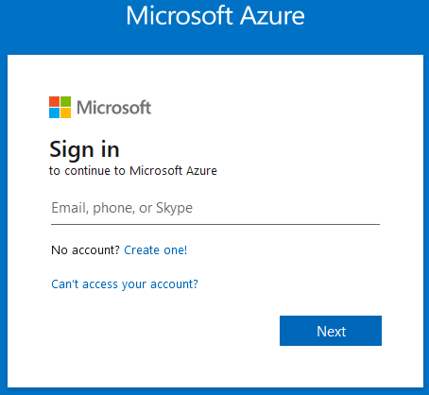  
Step 3: On the Create page, provide the following information.  
  
Name: Text12345678 -  
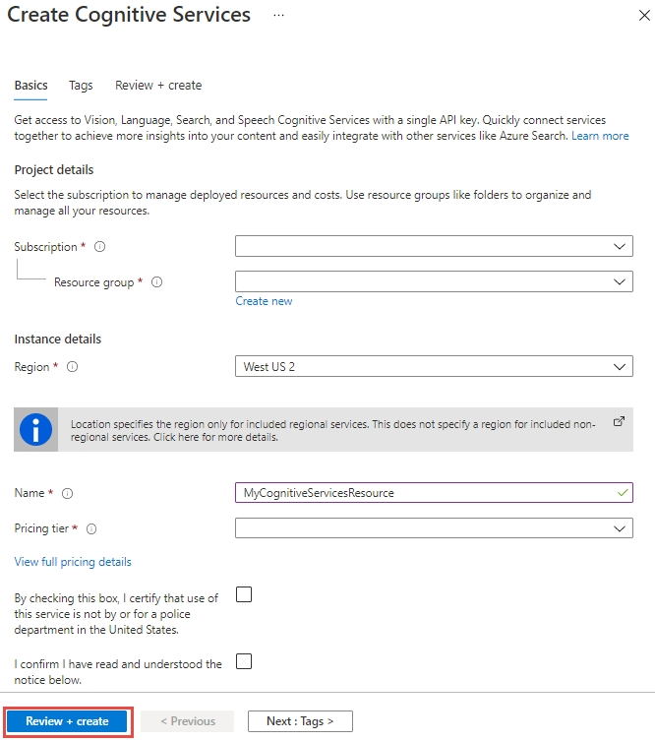  
Step 4: Configure additional settings for your resource as needed, read and accept the conditions (as applicable), and then select Review + create.  
Step 5: Navigate to the Azure portal. Then locate and select The Text Analytics service resource Text12345678 (which you created in Step 4).  
Step 6: Next, from the left-hand navigation menu, locate Monitoring and select Diagnostic settings. This screen contains all previously created diagnostic settings for this resource.  
Step 7: Select + Add diagnostic setting.  
Step 8: When prompted to configure, select the storage account and OMS workspace that you'd like to use to store you diagnostic logs. Note: If you don't have a storage account or OMS workspace, follow the prompts to create one.  
Step 9: Select Audit, RequestResponse, and AllMetrics. Then set the retention period for your diagnostic log data. If a retention policy is set to zero, events for that log category are stored indefinitely.  
Step 10: Click Save.  
It can take up to two hours before logging data is available to query and analyze. So don't worry if you don't see anything right away.  
Reference:  
https://docs.microsoft.com/en-us/azure/cognitive-services/cognitive-services-apis-create-account https://docs.microsoft.com/en-us/azure/cognitive-services/diagnostic-logging

Question #34*Topic 1*

SIMULATION -  
You need to create a search service named search12345678 that will index a sample Azure Cosmos DB database named hotels-sample. The solution must ensure that only English language fields are retrievable.  
To complete this task, sign in to the Azure portal.

**Correct Answer:** *See explanation below.*  
Part 1: Create a search service search12345678  
Step 1: Sign in to the QnA portal.  
Step 2: Create an Azure Cognitive multi-service resource:  
  
Step 3: On the Create page, provide the following information.  
  
Name: search12345678 -  
  
  
Step 4: Click Review + create -  
Part 2: Start the Import data wizard and create a data source  
Step 5: Click Import data on the command bar to create and populate a search index.  
  
Step 6: In the wizard, click Connect to your data > Samples > hotels-sample. This data source is built-in. If you were creating your own data source, you would need to specify a name, type, and connection information. Once created, it becomes an "existing data source" that can be reused in other import operations.  
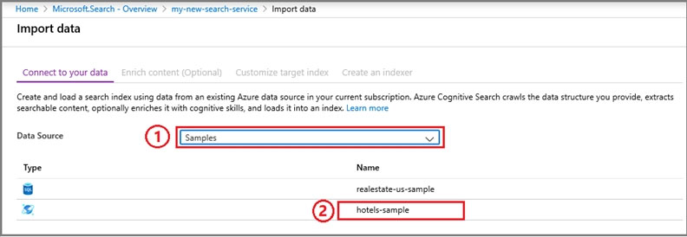  
Step 7: Continue to the next page.  
Step 8: Skip the "Enrich content" page  
Step 9: Configure index.  
Make sure English is selected for the fields.  
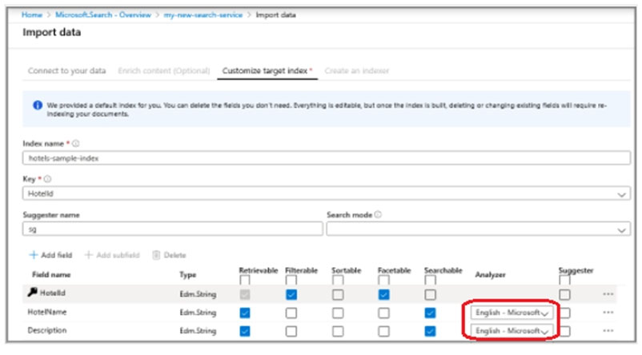  
Step 10: Continue and finish the wizard.  
Reference:  
https://docs.microsoft.com/en-us/azure/cognitive-services/cognitive-services-apis-create-account https://docs.microsoft.com/en-us/azure/search/search-get-started-portal

Question #35*Topic 1*

SIMULATION -  
You plan to create a solution to generate captions for images that will be read from Azure Blob Storage.  
You need to create a service in Azure Cognitive Services for the solution. The service must be named captions12345678 and must use the Free pricing tier.  
To complete this task, sign in to the Azure portal.

**Correct Answer:** *See explanation below.*  
Part 1: Create a search service captions12345678  
Step 1: Sign in to the QnA portal.  
Step 2: Create an Azure Cognitive multi-service resource:  
  
Step 3: On the Create page, provide the following information.  
Name: captions12345678ֲ¨  
  
Pricing tier: Free -  
  
  
Step 4: Click Review + create -  
(Step 5: Create a data source  
In Connect to your data, choose Azure Blob Storage. Choose an existing connection to the storage account and container you created. Give the data source a name, and use default values for the rest.)  
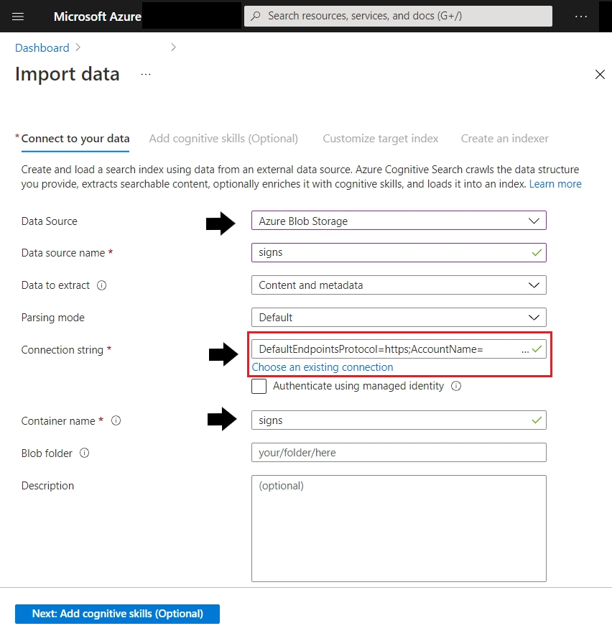  
Reference:  
https://docs.microsoft.com/en-us/azure/search/search-create-service-portal <https://docs.microsoft.com/en-us/azure/search/cognitive-search-quickstart-ocr>

Question #36*Topic 1*

SIMULATION -  
You need to create a Form Recognizer resource named fr12345678.  
Use the Form Recognizer sample labeling tool at https://fott-2-1.azurewebsites.net/ to analyze the invoice located in the C:\Resources\Invoices folder.  
Save the results as C:\Resources\Invoices\Results.json.  
To complete this task, sign in to the Azure portal and open the Form Recognizer sample labeling tool.

**Correct Answer:** *See explanation below.*  
Step 1: Sign in to the Azure Portal.  
Step 2: Navigate to the Form Recognizer Sample Tool (at https://fott-2-1.azurewebsites.net)  
Step 3: On the sample tool home page select Use prebuilt model to get data.  
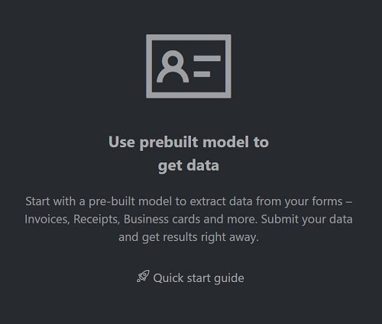  
Step 4: Select the Form Type you would like to analyze from the dropdown window.  
Step 5: In the Source: URL field, paste the selected URL and select the Fetch button.  
Step 6: In the Choose file for analysis use the file in the C:\Resources\Invoices folder and select the Fetch button.  
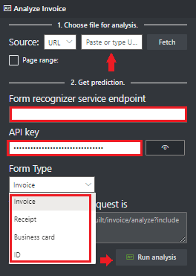  
Step 7: Select Run analysis. The Form Recognizer Sample Labeling tool will call the Analyze Prebuilt API and analyze the document.  
Step 8: View the results - see the key-value pairs extracted, line items, highlighted text extracted and tables detected.  
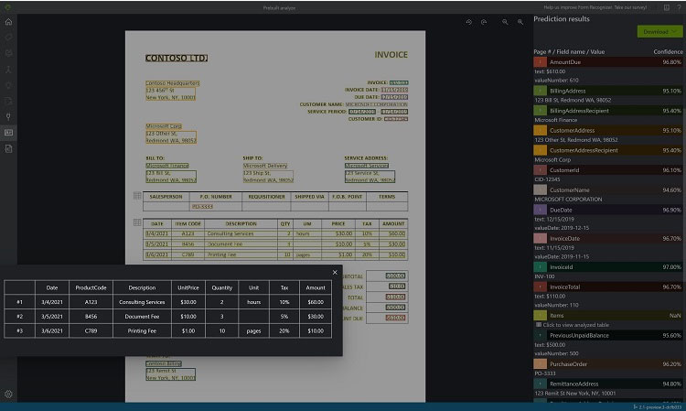  
Step 9: Save the results as C:\Resources\Invoices\Results.json.  
Reference:  
https://docs.microsoft.com/en-us/azure/applied-ai-services/form-recognizer/quickstarts/try-sample-label-tool

Question #37*Topic 1*

You have a factory that produces food products.  
You need to build a monitoring solution for staff compliance with personal protective equipment (PPE) requirements. The solution must meet the following requirements:  
* Identify staff who have removed masks or safety glasses.  
* Perform a compliance check every 15 minutes.  
* Minimize development effort.  
* Minimize costs.  
Which service should you use?

* A. Face
* B. Computer Vision
* C. Azure Video Analyzer for Media (formerly Video Indexer)

**Correct Answer:** *A* [🗳️](https://www.examtopics.com/exams/microsoft/ai-102/view/8/)  
Face API is an AI service that analyzes faces in images.  
Embed facial recognition into your apps for a seamless and highly secured user experience. No machine-learning expertise is required. Features include face detection that perceives facial features and attributes ג€" such as a face mask, glasses, or face location ג€" in an image, and identification of a person by a match to your private repository or via photo ID.  
Reference:  
https://azure.microsoft.com/en-us/services/cognitive-services/face/

Question #38*Topic 1*

You have an Azure Cognitive Search solution and a collection of blog posts that include a category field.  
You need to index the posts. The solution must meet the following requirements:  
* Include the category field in the search results.  
* Ensure that users can search for words in the category field.  
* Ensure that users can perform drill down filtering based on category.  
Which index attributes should you configure for the category field?

* A. searchable, sortable, and retrievable
* B. searchable, facetable, and retrievable
* C. retrievable, filterable, and sortable
* D. retrievable, facetable, and key
* **Correct Answer:** *C* [🗳️](https://www.examtopics.com/exams/microsoft/ai-102/view/8/)  
  Fields have data types and attributes. The check boxes across the top are index attributes controlling how the field is used.  
  * Retrievable means that it shows up in search results list. You can mark individual fields as off limits for search results by clearing this checkbox, for example for fields used only in filter expressions.  
  * Filterable, Sortable, and Facetable determine whether fields are used in a filter, sort, or faceted navigation structure.  
  * Searchable means that a field is included in full text search. Strings are searchable. Numeric fields and Boolean fields are often marked as not searchable.  
  Reference:  
  https://docs.microsoft.com/en-us/azure/search/search-get-started-portal
* Question #39*Topic 1*
* SIMULATION -  
  Use the following login credentials as needed:  
  To enter your username, place your cursor in the Sign in box and click on the username below.  
  To enter your password, place your cursor in the Enter password box and click on the password below.  
    
  Azure Username: admin@abc.com -  
    
  Azure Password: XXXXXXXXXXXX -  
  The following information is for technical support purposes only:  
    
  Lab Instance: 12345678 -  
    
  Task -  
  You plan to build an API that will identify whether an image includes a Microsoft Surface Pro or Surface Studio.  
  You need to deploy a service in Azure Cognitive Services for the API. The service must be named AAA12345678 and must be in the East US Azure region. The solution must use the Free pricing tier.  
  To complete this task, sign in to the Azure portal.
* **Correct Answer:** *See explanation below.*  
  Step 1: In the Azure dashboard, click Create a resource.  
  Step 2: In the search bar, type "Cognitive Services."  
  You'll get information about the cognitive services resource and a legal notice. Click Create.  
  Step 3: You'll need to specify the following details about the cognitive service (refer to the image below for a completed example of this page):  
  Subscription: choose your paid or trial subscription, depending on how you created your Azure account.  
  Resource group: click create new to create a new resource group or choose an existing one.  
  Region: choose the Azure region for your cognitive service. Choose: East US Azure region.  
  Name: choose a name for your cognitive service. Enter: AAA12345678  
  Pricing Tier: Select: Free pricing tier  
  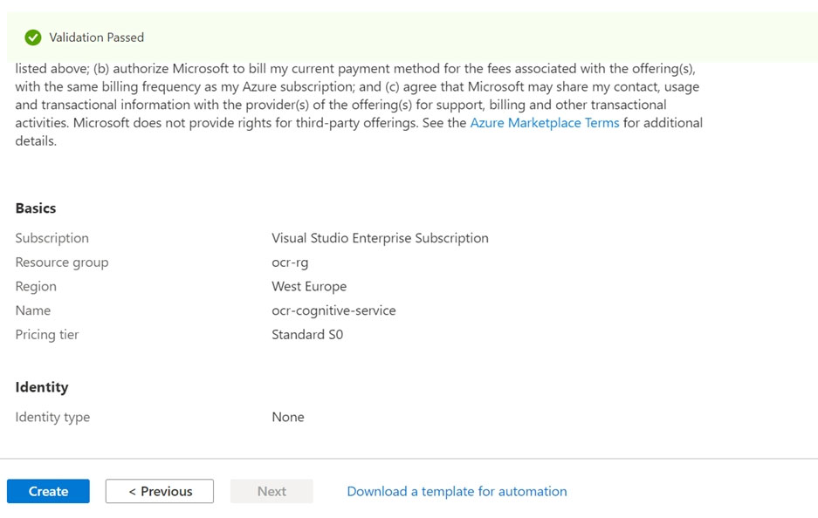  
  Step 4: Review and create the resource, and wait for deployment to complete. Then go to the deployed resource.  
  Note: The Computer Vision Image Analysis service can extract a wide variety of visual features from your images. For example, it can determine whether an image contains adult content, find specific brands or objects, or find human faces.  
    
  Tag visual features -  
  Identify and tag visual features in an image, from a set of thousands of recognizable objects, living things, scenery, and actions. When the tags are ambiguous or not common knowledge, the API response provides hints to clarify the context of the tag. Tagging isn't limited to the main subject, such as a person in the foreground, but also includes the setting (indoor or outdoor), furniture, tools, plants, animals, accessories, gadgets, and so on.  
  Try out the image tagging features quickly and easily in your browser using Vision Studio.  
  Reference:  
  https://docs.microsoft.com/en-us/learn/modules/analyze-images-computer-vision/3-analyze-images https://docs.microsoft.com/en-us/azure/cognitive-services/computer-vision/overview-image-analysis
* Question #40*Topic 1*
* SIMULATION -  
  Use the following login credentials as needed:  
  To enter your username, place your cursor in the Sign in box and click on the username below.  
  To enter your password, place your cursor in the Enter password box and click on the password below.  
    
  Azure Username: admin@abc.com -  
    
  Azure Password: XXXXXXXXXXXX -  
  The following information is for technical support purposes only:  
    
  Lab Instance: 12345678 -  
    
  Task -  
  You need to build an API that uses the service in Azure Cognitive Services named AAA12345678 to identify whether an image includes a Microsoft Surface Pro or  
  Surface Studio.  
  To achieve this goal, you must use the sample images in the C:\Resources\Images folder.  
  To complete this task, sign in to the Azure portal.

**Correct Answer:** *See explanation below.*  
Step 1: In the Azure dashboard, click Create a resource.  
Step 2: In the search bar, type "Cognitive Services."  
You'll get information about the cognitive services resource and a legal notice. Click Create.  
Step 3: You'll need to specify the following details about the cognitive service (refer to the image below for a completed example of this page):  
Subscription: choose your paid or trial subscription, depending on how you created your Azure account.  
Resource group: click create new to create a new resource group or choose an existing one.  
Region: choose the Azure region for your cognitive service. Choose: East US Azure region.  
Name: choose a name for your cognitive service. Enter: AAA12345678  
Pricing Tier: Select: Free pricing tier  
Step 4: Review and create the resource, and wait for deployment to complete. Then go to the deployed resource.  
Note: The Computer Vision Image Analysis service can extract a wide variety of visual features from your images. For example, it can determine whether an image contains adult content, find specific brands or objects, or find human faces.  
  
Tag visual features -  
Identify and tag visual features in an image, from a set of thousands of recognizable objects, living things, scenery, and actions. When the tags are ambiguous or not common knowledge, the API response provides hints to clarify the context of the tag. Tagging isn't limited to the main subject, such as a person in the foreground, but also includes the setting (indoor or outdoor), furniture, tools, plants, animals, accessories, gadgets, and so on.  
Try out the image tagging features quickly and easily in your browser using Vision Studio.  
Reference:  
https://docs.microsoft.com/en-us/learn/modules/analyze-images-computer-vision/3-analyze-images <https://docs.microsoft.com/en-us/azure/cognitive-services/computer-vision/overview-image-analysis>

Question #41*Topic 1*

SIMULATION -  
Use the following login credentials as needed:  
To enter your username, place your cursor in the Sign in box and click on the username below.  
To enter your password, place your cursor in the Enter password box and click on the password below.  
  
Azure Username: admin@abc.com -  
  
Azure Password: XXXXXXXXXXXX -  
The following information is for technical support purposes only:  
  
Lab Instance: 12345678 -  
  
Task -  
You need to get insights from a video file located in the C:\Resources\Video\Media.mp4 folder.  
Save the insights to the C:\Resources\Video\Insights.json folder.  
To complete this task, sign in to the Azure Video Analyzer for Media at https://www.videoindexer.ai/ by using admin@abc.com

**Correct Answer:** *See explanation below.*  
Step 1: Login -  
Browse to the Azure Video Indexer website and sign in.  
URL: https://www.videoindexer.ai/  
  
Login admin@abc.com -  
Step 2: Create a project from your video  
You can create a new project directly from a video in your account.  
1. Go to the Library tab of the Azure Video Indexer website.  
2. Open the video that you want to use to create your project. On the insights and timeline page, select the Video editor button.  
Folder: C:\Resources\Video\Media.mp4  
This takes you to the same page that you used to create a new project. Unlike the new project, you see the timestamped insights segments of the video, that you had started editing previously.  
Step 3: Save the insights to the C:\Resources\Video\Insights.json folder.  
Reference:  
<https://docs.microsoft.com/en-us/azure/azure-video-indexer/use-editor-create-project>

Question #42*Topic 1*

SIMULATION -  
Use the following login credentials as needed:  
To enter your username, place your cursor in the Sign in box and click on the username below.  
To enter your password, place your cursor in the Enter password box and click on the password below.  
  
Azure Username: admin@abc.com -  
  
Azure Password: XXXXXXXXXXXX -  
The following information is for technical support purposes only:  
  
Lab Instance: 12345678 -  
  
Task -  
You plan to analyze stock photography and automatically generate captions for the images.  
You need to create a service in Azure to analyze the images. The service must be named caption12345678 and must be in the East US Azure region. The solution must use the Free pricing tier.  
In the C:\Resources\Caption\Params.json folder, enter the value for Key 1 and the endpoint for the new service.  
To complete this task, sign in to the Azure portal.

[Hide Solution](https://www.examtopics.com/exams/microsoft/ai-102/view/9/) [Discussion   **5**](https://www.examtopics.com/exams/microsoft/ai-102/view/9/)

**Correct Answer:** *ן¼‹See explanation below.*  
Step 1: Provision a Cognitive Services resource  
If you don't already have one in your subscription, you'll need to provision a Cognitive Services resource.  
1. Open the Azure portal at https://portal.azure.com, and sign in using the Microsoft account associated with your Azure subscription.  
2. Select the Create a resource button, search for cognitive services, and create a Cognitive Services resource with the following settings:  
Subscription: Your Azure subscription  
Resource group: Choose or create a resource group (if you are using a restricted subscription, you may not have permission to create a new resource group - use the one provided)  
  
Region: East US Azure region -  
  
Name: caption12345678 -  
  
Pricing tier: Free F0 -  
3. Select the required checkboxes and create the resource.  
Wait for deployment to complete, and then view the deployment details.  
4. When the resource has been deployed, go to it and view its Keys and Endpoint page. You will need the endpoint and one of the keys from this page in the next procedure.  
Step 2: Save Key and Endpoint values in Params.json  
Open the configuration file, C:\Resources\Caption\Params.json. and update the configuration values it contains to reflect the endpoint and an authentication key for your cognitive services resource. Save your changes.  
Reference:  
https://microsoftlearning.github.io/AI-102-AIEngineer/Instructions/15-computer-vision.html

Question #43*Topic 1*

SIMULATION -  
Use the following login credentials as needed:  
To enter your username, place your cursor in the Sign in box and click on the username below.  
To enter your password, place your cursor in the Enter password box and click on the password below.  
  
Azure Username: admin@abc.com -  
  
Azure Password: XXXXXXXXXXXX -  
The following information is for technical support purposes only:  
  
Lab Instance: 12345678 -  
  
Task -  
You plan to build an application that will use caption12345678. The application will be deployed to a virtual network named VNet1.  
You need to ensure that only virtual machines on VNet1 can access caption12345678.  
To complete this task, sign in to the Azure portal.

**Correct Answer:** *See explanation below.*  
Step 1: Create private endpoint for your web app  
1. In the left-hand menu, select All Resources > caption12345678 - the name of your web app.  
2. In the web app overview, select Settings > Networking.  
3. In Networking, select Private endpoints.  
4. Select + Add in the Private Endpoint connections page.  
5. Enter or select the following information in the Add Private Endpoint page:  
Name: Enter caption12345678.  
Subscription Select your Azure subscription.  
Virtual network Select VNet1.  
Subnet: -  
Integrate with private DNS zone: Select Yes.  
6. Select OK.  
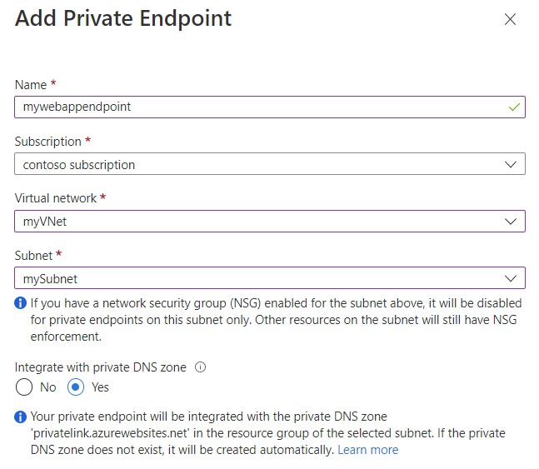  
Reference:  
https://docs.microsoft.com/en-us/azure/private-link/tutorial-private-endpoint-webapp-portal

Question #44*Topic 1*

SIMULATION -  
Use the following login credentials as needed:  
To enter your username, place your cursor in the Sign in box and click on the username below.  
To enter your password, place your cursor in the Enter password box and click on the password below.  
  
Azure Username: admin@abc.com -  
  
Azure Password: XXXXXXXXXXXX -  
The following information is for technical support purposes only:  
  
Lab Instance: 12345678 -  
  
Task -  
You need to ensure that a user named admin@abc.com can regenerate the subscription keys of AAA12345678. The solution must use the principle of least privilege.  
To complete this task, sign in to the Azure portal.

**Correct Answer:** *See explanation below.*  
Manually rotate subscription keys  
1. (Update your application code to reference the secondary key for the Azure account and deploy.)  
2. In the Azure portal, navigate to your Azure account.  
3. Under Settings, select Authentication.  
4. To regenerate the primary key for your Azure account, select the Regenerate button next to the primary key.  
5. (Update your application code to reference the new primary key and deploy.)  
6. Regenerate the secondary key in the same manner.  
Reference:  
https://github.com/MicrosoftDocs/azure-docs/blob/main/articles/azure-maps/how-to-manage-authentication.md

Question #45*Topic 1*

You have an Azure IoT hub that receives sensor data from machinery.  
  
You need to build an app that will perform the following actions:  
  
• Perform anomaly detection across multiple correlated sensors.  
• Identify the root cause of process stops.  
• Send incident alerts.  
  
The solution must minimize development time.  
  
Which Azure service should you use?

* A. Azure Metrics Advisor **Most Voted**
* B. Form Recognizer
* C. Azure Machine Learning
* D. Anomaly Detector

Question #46*Topic 1*

You have an app that analyzes images by using the Computer Vision API.  
  
You need to configure the app to provide an output for users who are vision impaired. The solution must provide the output in complete sentences.  
  
Which API call should you perform?

* A. readInStreamAsync
* B. analyzeImagesByDomainInStreamAsync
* C. tagImageInStreamAsync
* D. describeImageInStreamAsync **Most Vote**
* Question #47*Topic 1*
* DRAG DROP  
  -  
    
  You have a Custom Vision service project that performs object detection. The project uses the General domain for classification and contains a trained model.  
    
  You need to export the model for use on a network that is disconnected from the internet.  
    
  Which three actions should you perform in sequence? To answer, move the appropriate actions from the list of actions to the answer area and arrange them in the correct order.
* 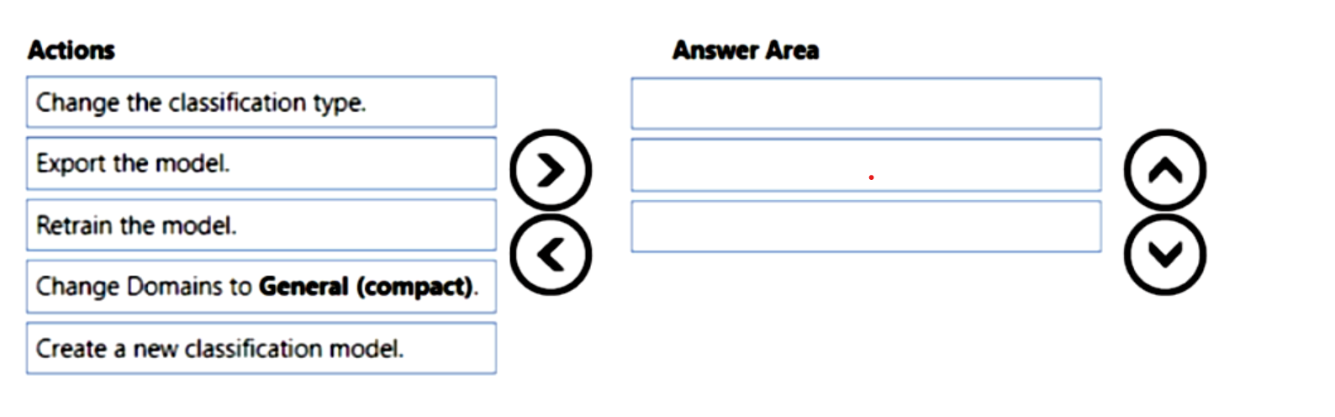

**Correct Answer:** 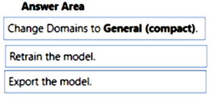

Question #48*Topic 1*

You are building an AI solution that will use Sentiment Analysis results from surveys to calculate bonuses for customer service staff.  
  
You need to ensure that the solution meets the Microsoft responsible AI principles.  
  
What should you do?

* A. Add a human review and approval step before making decisions that affect the staff's financial situation. **Most Voted**
* B. Include the Sentiment Analysis results when surveys return a low confidence score.
* C. Use all the surveys, including surveys by customers who requested that their account be deleted and their data be removed.
* D. Publish the raw survey data to a central location and provide the staff with access to the location.

**Correct Answer:** *A* [🗳️](https://www.examtopics.com/exams/microsoft/ai-102/view/10/)

A (100%)

Question #49*Topic 1*

You have an Azure subscription that contains a Language service resource named ta1 and a virtual network named vnet1.  
  
You need to ensure that only resources in vnet1 can access ta1.  
  
What should you configure?

* A. a network security group (NSG) for vnet1
* B. Azure Firewall for vnet1
* C. the virtual network settings for ta1 **Most Voted**
* D. a Language service container for ta1

**Correct Answer:** *C* [🗳️](https://www.examtopics.com/exams/microsoft/ai-102/view/10/)

Question #50*Topic 1*

You are developing a monitoring system that will analyze engine sensor data, such as rotation speed, angle, temperature, and pressure. The system must generate an alert in response to a typical value.  
  
What should you include in the solution?

* A. Application Insights in Azure Monitor
* B. metric alerts in Azure Monitor
* C. Multivariate Anomaly Detection **Most Voted**
* D. Univariate Anomaly Detection

Question #51*Topic 1*

You have an app named App1 that uses an Azure Cognitive Services model to identify anomalies in a time series data stream.  
  
You need to run App1 in a location that has limited connectivity. The solution must minimize costs.  
  
What should you use to host the model?

* A. Azure Kubernetes Service (AKS)
* B. Azure Container Instances **Most Voted**
* C. a Kubernetes cluster hosted in an Azure Stack Hub integrated system
* D. the Docker Engine **Most Voted**

[Hide Solution](https://www.examtopics.com/exams/microsoft/ai-102/view/11/) [Discussion   **31**](https://www.examtopics.com/exams/microsoft/ai-102/view/11/)

**Correct Answer:** *C* [🗳️](https://www.examtopics.com/exams/microsoft/ai-102/view/11/)

*Community vote distribution*

D (47%)

B (44%)

9%

Question #52*Topic 1*

HOTSPOT  
-  
  
You have an Azure Cognitive Search resource named Search1 that is used by multiple apps.  
  
You need to secure Search1. The solution must meet the following requirements:  
  
• Prevent access to Search1 from the internet.  
• Limit the access of each app to specific queries.  
  
What should you do? To answer, select the appropriate options in the answer area.  
  
NOTE: Each correct selection is worth one point.  
  
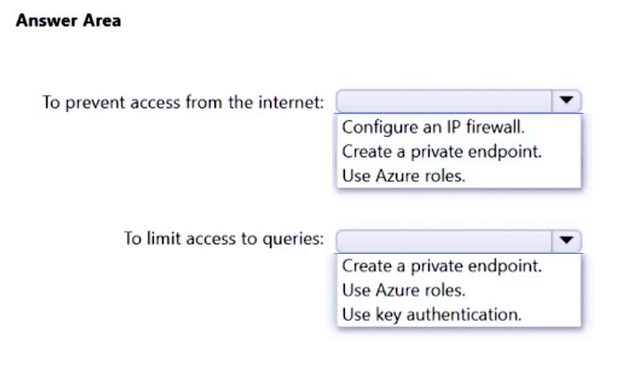

[Hide Solution](https://www.examtopics.com/exams/microsoft/ai-102/view/11/) [Discussion   **20**](https://www.examtopics.com/exams/microsoft/ai-102/view/11/)

**Correct Answer:** 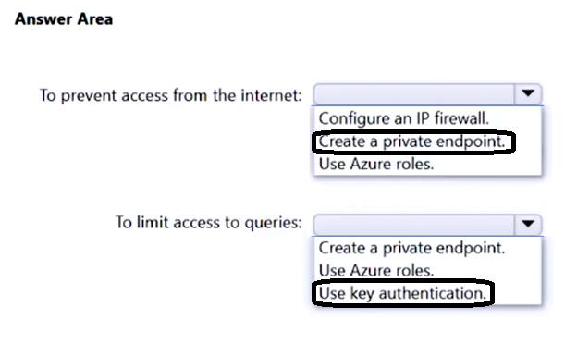

Question #53*Topic 1*

You are building a solution that will detect anomalies in sensor data from the previous 24 hours.  
  
You need to ensure that the solution scans the entire dataset, at the same time, for anomalies.  
  
Which type of detection should you use?

* A. batch **Most Voted**
* B. streaming
* C. change points

[Hide Solution](https://www.examtopics.com/exams/microsoft/ai-102/view/11/) [Discussion   **9**](https://www.examtopics.com/exams/microsoft/ai-102/view/11/)

**Correct Answer:** *A* [🗳️](https://www.examtopics.com/exams/microsoft/ai-102/view/11/)

*Community vote distribution*

A (100%)

Question #54*Topic 1*

DRAG DROP  
-  
  
You are building an app that will scan confidential documents and use the Language service to analyze the contents.  
  
You provision an Azure Cognitive Services resource.  
  
You need to ensure that the app can make requests to the Language service endpoint. The solution must ensure that confidential documents remain on-premises.  
  
Which three actions should you perform in sequence? To answer, move the appropriate actions from the list of actions to the answer area and arrange them in the correct order.  
  
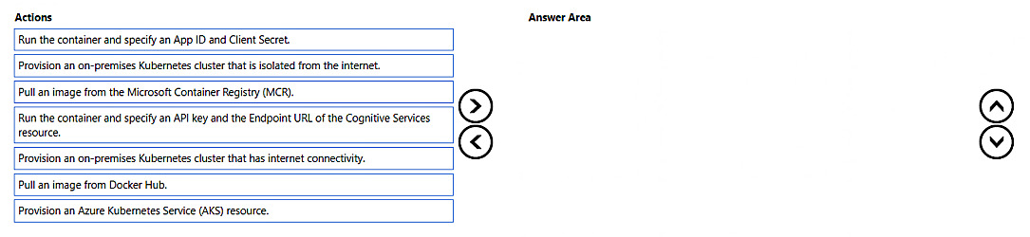

[Hide Solution](https://www.examtopics.com/exams/microsoft/ai-102/view/11/) [Discussion   **21**](https://www.examtopics.com/exams/microsoft/ai-102/view/11/)

**Correct Answer:** 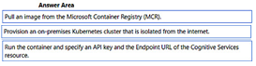

Question #55*Topic 1*

HOTSPOT  
-  
  
You have an Azure subscription that has the following configurations:  
  
• Subscription ID: 8d3591aa-96b8-4737-ad09-00f9b1ed35ad  
• Tenant ID: 3edfe572-cb54-3ced-ae12-c5c177f39a12  
  
You plan to create a resource that will perform sentiment analysis and optical character recognition (OCR).  
  
You need to use an HTTP request to create the resource in the subscription. The solution must use a single key and endpoint.  
  
How should you complete the request? To answer, select the appropriate options in the answer area.  
  
NOTE: Each correct selection is worth one point.  
  
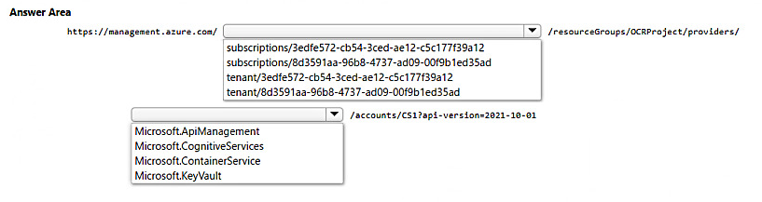

[Hide Solution](https://www.examtopics.com/exams/microsoft/ai-102/view/11/) [Discussion   **6**](https://www.examtopics.com/exams/microsoft/ai-102/view/11/)

**Correct Answer:** 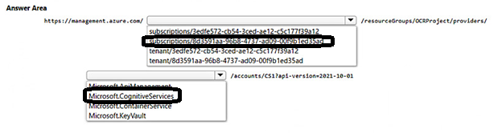

Question #56*Topic 1*

You have an Azure subscription that contains an Anomaly Detector resource.  
  
You deploy a Docker host server named Server1 to the on-premises network.  
  
You need to host an instance of the Anomaly Detector service on Server1.  
  
Which parameter should you include in the docker run command?

* A. Fluentd
* B. Billing **Most Voted**
* C. Http Proxy
* D. Mounts

[Hide Solution](https://www.examtopics.com/exams/microsoft/ai-102/view/12/) [Discussion   **15**](https://www.examtopics.com/exams/microsoft/ai-102/view/12/)

**Correct Answer:** *B* [🗳️](https://www.examtopics.com/exams/microsoft/ai-102/view/12/)

*Community vote distribution*

B (82%)

D (18%)

Question #57*Topic 1*

You are building an app that will use the Speech service.  
  
You need to ensure that the app can authenticate to the service by using a Microsoft Azure Active Directory (Azure AD), part of Microsoft Entra, token.  
  
Which two actions should you perform? Each correct answer presents part of the solution.  
  
NOTE: Each correct selection is worth one point.

* A. Enable a virtual network service endpoint.
* B. Configure a custom subdomain. **Most VotedMost Voted**
* C. Request an X.509 certificate.
* D. Create a private endpoint. **Most Voted**
* E. Create a Conditional Access policy. **Most Voted**

[Hide Solution](https://www.examtopics.com/exams/microsoft/ai-102/view/12/) [Discussion   **24**](https://www.examtopics.com/exams/microsoft/ai-102/view/12/)

**Correct Answer:** *CE* [🗳️](https://www.examtopics.com/exams/microsoft/ai-102/view/12/)

*Community vote distribution*

BD (64%)

BE (31%)

5%

Question #58*Topic 1*

HOTSPOT  
-  
  
You plan to deploy an Azure OpenAI resource by using an Azure Resource Manager (ARM) template.  
  
You need to ensure that the resource can respond to 600 requests per minute.  
  
How should you complete the template? To answer, select the appropriate options in the answer area.  
  
NOTE: Each correct selection is worth one point.  
  
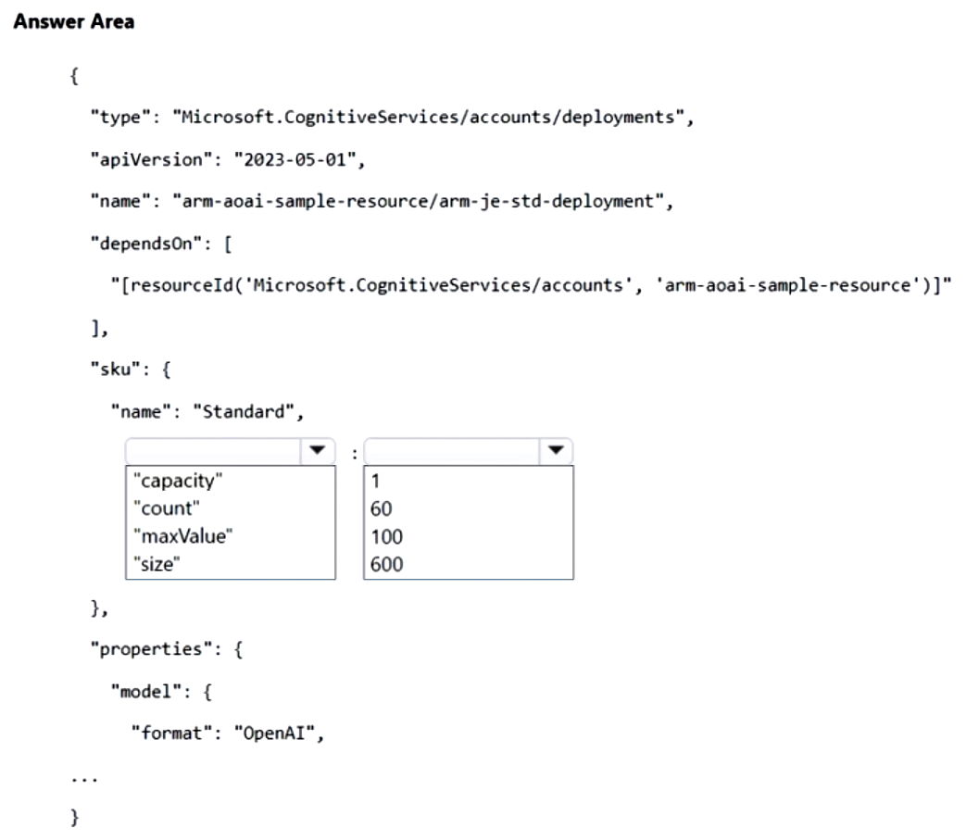

[Hide Solution](https://www.examtopics.com/exams/microsoft/ai-102/view/12/) [Discussion   **9**](https://www.examtopics.com/exams/microsoft/ai-102/view/12/)

**Correct Answer:** 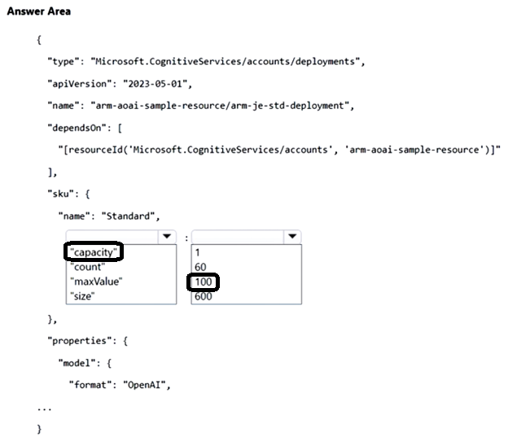

Question #59*Topic 1*

DRAG DROP  
-  
  
You have an app that manages feedback.  
  
You need to ensure that the app can detect negative comments by using the Sentiment Analysis API in Azure AI Language. The solution must ensure that the managed feedback remains on your company’s internal network.  
  
Which three actions should you perform in sequence? To answer, move the appropriate actions from the list of actions to the answer area and arrange them in the correct order.  
  
NOTE: More than one order of answer choices is correct. You will receive credit for any of the correct orders you select.  
  
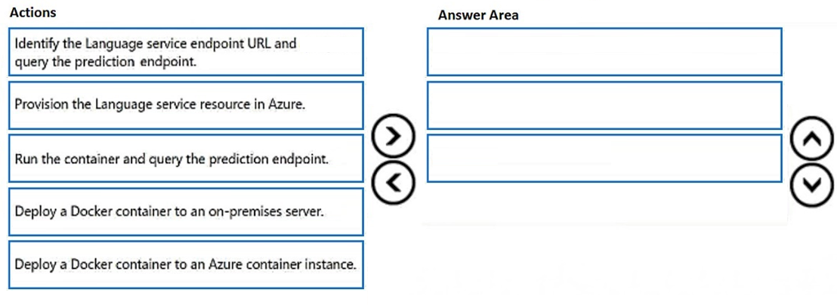

[Hide Solution](https://www.examtopics.com/exams/microsoft/ai-102/view/12/) [Discussion   **9**](https://www.examtopics.com/exams/microsoft/ai-102/view/12/)

**Correct Answer:** 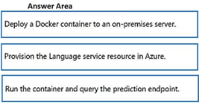

Question #60*Topic 1*

HOTSPOT  
-  
  
You have an Azure OpenAI resource named AI1 that hosts three deployments of the GPT 3.5 model. Each deployment is optimized for a unique workload.  
  
You plan to deploy three apps. Each app will access AI1 by using the REST API and will use the deployment that was optimized for the app's intended workload.  
  
You need to provide each app with access to AI1 and the appropriate deployment. The solution must ensure that only the apps can access AI1.  
  
What should you use to provide access to AI1, and what should each app use to connect to its appropriate deployment? To answer, select the appropriate options in the answer area.  
  
NOTE: Each correct selection is worth one point.  
  
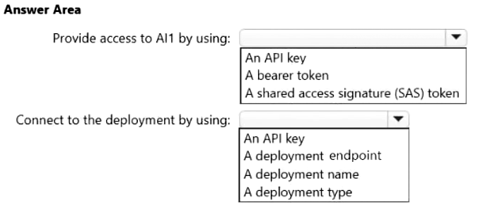

[Hide Solution](https://www.examtopics.com/exams/microsoft/ai-102/view/12/) [Discussion   **17**](https://www.examtopics.com/exams/microsoft/ai-102/view/12/)

**Correct Answer:** 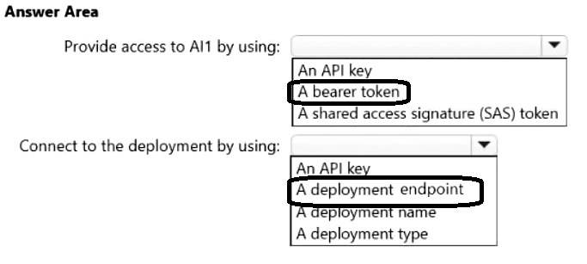

Question #61*Topic 1*

You build a bot by using the Microsoft Bot Framework SDK.  
  
You start the bot on a local computer.  
  
You need to validate the functionality of the bot.  
  
What should you do before you connect to the bot?

* A. Run the Bot Framework Emulator.
* B. Run the Bot Framework Composer.
* C. Register the bot with Azure Bot Service.
* D. Run Windows Terminal.

[Hide Solution](https://www.examtopics.com/exams/microsoft/ai-102/view/13/) [Discussion   **6**](https://www.examtopics.com/exams/microsoft/ai-102/view/13/)

**Correct Answer:** *A* [🗳️](https://www.examtopics.com/exams/microsoft/ai-102/view/13/)

*Community vote distribution*

A (100%)

Question #62*Topic 1*

You have an Azure OpenAI model named AI1.  
  
You are building a web app named App1 by using the Azure OpenAI SDK.  
  
You need to configure App1 to connect to AI1.  
  
What information must you provide?

* A. the endpoint, key, and model name
* B. the deployment name, key, and model name
* C. the deployment name, endpoint, and key **Most Voted**
* D. the endpoint, key, and model type

[Hide Solution](https://www.examtopics.com/exams/microsoft/ai-102/view/13/) [Discussion   **11**](https://www.examtopics.com/exams/microsoft/ai-102/view/13/)

**Correct Answer:** *C* [🗳️](https://www.examtopics.com/exams/microsoft/ai-102/view/13/)

*Community vote distribution*

C (100%)

Question #63*Topic 1*

You are building a solution in Azure that will use Azure Cognitive Service for Language to process sensitive customer data.  
  
You need to ensure that only specific Azure processes can access the Language service. The solution must minimize administrative effort.  
  
What should you include in the solution?

* A. IPsec rules
* B. Azure Application Gateway
* C. a virtual network gateway
* D. virtual network rules **Most Voted**

[Hide Solution](https://www.examtopics.com/exams/microsoft/ai-102/view/13/) [Discussion   **4**](https://www.examtopics.com/exams/microsoft/ai-102/view/13/)

**Correct Answer:** *D* [🗳️](https://www.examtopics.com/exams/microsoft/ai-102/view/13/)

*Community vote distribution*

D (100%)

Question #64*Topic 1*

You plan to perform predictive maintenance.  
  
You collect IoT sensor data from 100 industrial machines for a year. Each machine has 50 different sensors that generate data at one-minute intervals. In total, you have 5,000 time series datasets.  
  
You need to identify unusual values in each time series to help predict machinery failures.  
  
Which Azure service should you use?

* A. Azure AI Computer Vision
* B. Cognitive Search
* C. Azure AI Document Intelligence
* D. Azure AI Anomaly Detector **Most Voted**

[Hide Solution](https://www.examtopics.com/exams/microsoft/ai-102/view/13/) [Discussion   **6**](https://www.examtopics.com/exams/microsoft/ai-102/view/13/)

**Correct Answer:** *D* [🗳️](https://www.examtopics.com/exams/microsoft/ai-102/view/13/)

*Community vote distribution*

D (100%)

Question #65*Topic 1*

HOTSPOT  
-  
  
You plan to deploy a containerized version of an Azure Cognitive Services service that will be used for sentiment analysis.  
  
You configure https://contoso.cognitiveservices.azure.com as the endpoint URI for the service.  
  
You need to run the container on an Azure virtual machine by using Docker.  
  
How should you complete the command? To answer, select the appropriate options in the answer area.  
  
NOTE: Each correct selection is worth one point.  
  
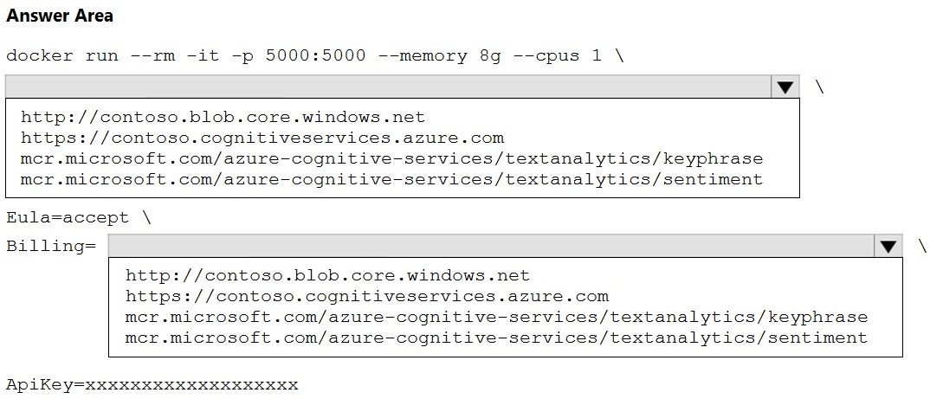

[Hide Solution](https://www.examtopics.com/exams/microsoft/ai-102/view/13/) [Discussion   **3**](https://www.examtopics.com/exams/microsoft/ai-102/view/13/)

**Correct Answer:** 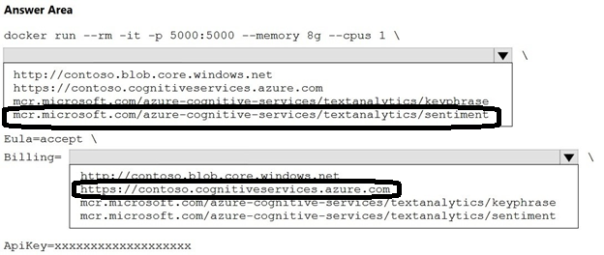

Question #66*Topic 1*

You are developing a system that will monitor temperature data from a data stream. The system must generate an alert in response to atypical values. The solution must minimize development effort.  
  
What should you include in the solution?

* A. Multivariate Anomaly Detection
* B. Azure Stream Analytics
* C. metric alerts in Azure Monitor
* D. Univariate Anomaly Detection **Most Voted**

[Hide Solution](https://www.examtopics.com/exams/microsoft/ai-102/view/14/) [Discussion   **18**](https://www.examtopics.com/exams/microsoft/ai-102/view/14/)

**Correct Answer:** *D* [🗳️](https://www.examtopics.com/exams/microsoft/ai-102/view/14/)

*Community vote distribution*

D (44%)

C (28%)

B (28%)

Question #67*Topic 1*

You have a Microsoft OneDrive folder that contains a 20-GB video file named File1.avi.  
  
You need to index File1.avi by using the Azure Video Indexer website.  
  
What should you do?

* A. Upload File1.avi to the www.youtube.com webpage, and then copy the URL of the video to the Azure AI Video Indexer website.
* B. Download File1.avi to a local computer, and then upload the file to the Azure AI Video Indexer website.
* C. From OneDrive, create a download link, and then copy the link to the Azure AI Video Indexer website. **Most Voted**
* D. From OneDrive, create a sharing link for File1.avi, and then copy the link to the Azure AI Video Indexer website.

[Hide Solution](https://www.examtopics.com/exams/microsoft/ai-102/view/14/) [Discussion   **11**](https://www.examtopics.com/exams/microsoft/ai-102/view/14/)

**Correct Answer:** *C* [🗳️](https://www.examtopics.com/exams/microsoft/ai-102/view/14/)

*Community vote distribution*

C (84%)

D (16%)

Question #68*Topic 1*

You have an Azure subscription that contains an Azure AI Service resource named CSAccount1 and a virtual network named VNet1. CSAaccount1 is connected to VNet1.  
  
You need to ensure that only specific resources can access CSAccount1. The solution must meet the following requirements:  
  
• Prevent external access to CSAccount1.  
• Minimize administrative effort.  
  
Which two actions should you perform? Each correct answer presents part of the solution.  
  
NOTE: Each correct answer is worth one point.

* A. In VNet1, enable a service endpoint for CSAccount1. **Most Voted**
* B. In CSAccount1, configure the Access control (IAM) settings.
* C. In VNet1, modify the virtual network settings.
* D. In VNet1, create a virtual subnet.
* E. In CSAccount1, modify the virtual network settings. **Most Voted**

[Hide Solution](https://www.examtopics.com/exams/microsoft/ai-102/view/14/) [Discussion   **17**](https://www.examtopics.com/exams/microsoft/ai-102/view/14/)

**Correct Answer:** *AD* [🗳️](https://www.examtopics.com/exams/microsoft/ai-102/view/14/)

*Community vote distribution*

AE (66%)

AB (28%)

7%

Question #69*Topic 1*

You are building an internet-based training solution. The solution requires that a user's camera and microphone remain enabled.  
  
You need to monitor a video stream of the user and detect when the user asks an instructor a question. The solution must minimize development effort.  
  
What should you include in the solution?

* A. speech-to-text in the Azure AI Speech service **Most Voted**
* B. language detection in Azure AI Language Service
* C. the Face service in Azure AI Vision
* D. object detection in Azure AI Custom Vision

[Hide Solution](https://www.examtopics.com/exams/microsoft/ai-102/view/14/) [Discussion   **14**](https://www.examtopics.com/exams/microsoft/ai-102/view/14/)

**Correct Answer:** *A* [🗳️](https://www.examtopics.com/exams/microsoft/ai-102/view/14/)

*Community vote distribution*

A (100%)

## Topic 2 - Question Set 2

Question #1*Topic 2*

HOTSPOT -  
You are developing an application that will use the Computer Vision client library. The application has the following code.  
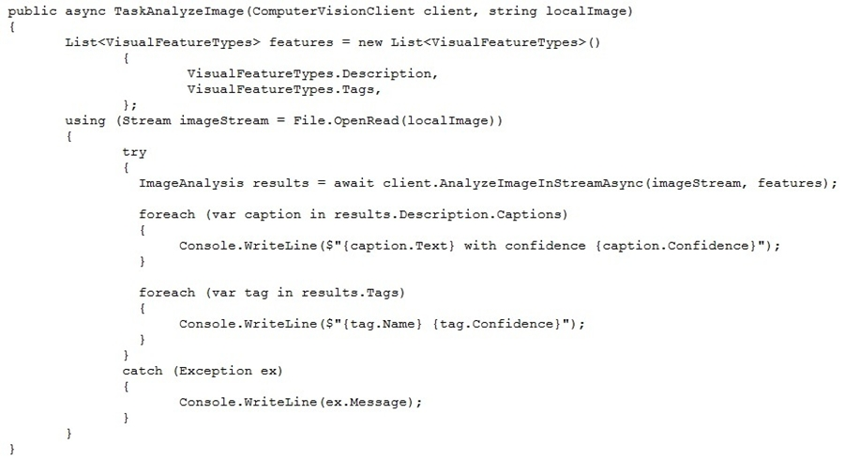  
For each of the following statements, select Yes if the statement is true. Otherwise, select No.  
NOTE: Each correct selection is worth one point.  
Hot Area:  
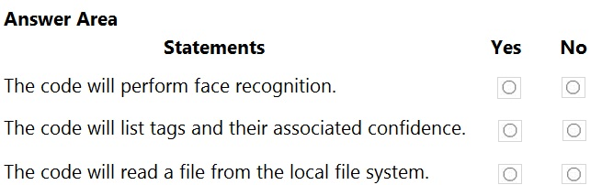

[Hide Solution](https://www.examtopics.com/exams/microsoft/ai-102/view/14/) [Discussion   **23**](https://www.examtopics.com/exams/microsoft/ai-102/view/14/)

**Correct Answer:** 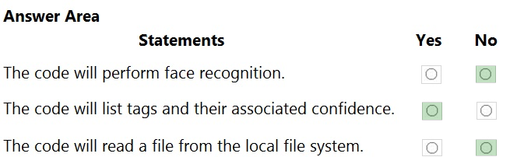  
Box 1: No -  
  
Box 2: Yes -  
The ComputerVision.analyzeImageInStreamAsync operation extracts a rich set of visual features based on the image content.  
  
Box 3: No -  
Images will be read from a stream.  
Reference:  
<https://docs.microsoft.com/en-us/java/api/com.microsoft.azure.cognitiveservices.vision.computervision.computervision.analyzeimageinstreamasync>

##### **Question 1**

You build a bot by using the Microsoft Bot Framework SDK.  
  
You start the bot on a local computer.  
  
You need to validate the functionality of the bot.  
  
What should you do before you connect to the bot?

* **A.**Run the Bot Framework Emulator.
* **B.**Run the Bot Framework Composer.
* **C.**Register the bot with Azure Bot Service.
* **D.**Run Windows Terminal.

Answer : **A**

Next Question

##### **Question 2**

You have an Azure OpenAI model named AI1.  
  
You are building a web app named App1 by using the Azure OpenAI SDK.  
  
You need to configure App1 to connect to AI1.  
  
What information must you provide?

* **A.**the endpoint, key, and model name
* **B.**the deployment name, key, and model name
* **C.**the deployment name, endpoint, and key
* **D.**the endpoint, key, and model type

Answer : **C**

Next Question

##### **Question 3**

You are building a solution in Azure that will use Azure Cognitive Service for Language to process sensitive customer data.  
  
You need to ensure that only specific Azure processes can access the Language service. The solution must minimize administrative effort.  
  
What should you include in the solution?

* **A.**IPsec rules
* **B.**Azure Application Gateway
* **C.**a virtual network gateway
* **D.**virtual network rules

Answer : **D**

Next Question

##### **Question 4**

You plan to perform predictive maintenance.  
  
You collect IoT sensor data from 100 industrial machines for a year. Each machine has 50 different sensors that generate data at one-minute intervals. In total, you have 5,000 time series datasets.  
  
You need to identify unusual values in each time series to help predict machinery failures.  
  
Which Azure service should you use?

* **A.**Azure AI Computer Vision
* **B.**Cognitive Search
* **C.**Azure AI Document Intelligence
* **D.**Azure AI Anomaly Detector

Answer : **D**

Next Question

##### **Question 5**

HOTSPOT  
-  
  
You plan to deploy a containerized version of an Azure Cognitive Services service that will be used for sentiment analysis.  
  
You configure https://contoso.cognitiveservices.azure.com as the endpoint URI for the service.  
  
You need to run the container on an Azure virtual machine by using Docker.  
  
How should you complete the command? To answer, select the appropriate options in the answer area.  
  
NOTE: Each correct selection is worth one point.  
  


Answer : 

Next Question

##### **Question 6**

You are developing a system that will monitor temperature data from a data stream. The system must generate an alert in response to atypical values. The solution must minimize development effort.  
  
What should you include in the solution?

* **A.**Multivariate Anomaly Detection
* **B.**Azure Stream Analytics
* **C.**metric alerts in Azure Monitor
* **D.**Univariate Anomaly Detection

Answer : **D**

Next Question

##### **Question 7**

You have a Microsoft OneDrive folder that contains a 20-GB video file named File1.avi.  
  
You need to index File1.avi by using the Azure Video Indexer website.  
  
What should you do?

* **A.**Upload File1.avi to the www.youtube.com webpage, and then copy the URL of the video to the Azure AI Video Indexer website.
* **B.**Download File1.avi to a local computer, and then upload the file to the Azure AI Video Indexer website.
* **C.**From OneDrive, create a download link, and then copy the link to the Azure AI Video Indexer website.
* **D.**From OneDrive, create a sharing link for File1.avi, and then copy the link to the Azure AI Video Indexer website.

Answer : **C**

Next Question

##### **Question 8**

You have an Azure subscription that contains an Azure AI Service resource named CSAccount1 and a virtual network named VNet1. CSAaccount1 is connected to VNet1.  
  
You need to ensure that only specific resources can access CSAccount1. The solution must meet the following requirements:  
  
• Prevent external access to CSAccount1.  
• Minimize administrative effort.  
  
Which two actions should you perform? Each correct answer presents part of the solution.  
  
NOTE: Each correct answer is worth one point.

* **A.**In VNet1, enable a service endpoint for CSAccount1.
* **B.**In CSAccount1, configure the Access control (IAM) settings.
* **C.**In VNet1, modify the virtual network settings.
* **D.**In VNet1, create a virtual subnet.
* **E.**In CSAccount1, modify the virtual network settings.

Answer : **AD**

Next Question

##### **Question 9**

You are building an internet-based training solution. The solution requires that a user's camera and microphone remain enabled.  
  
You need to monitor a video stream of the user and detect when the user asks an instructor a question. The solution must minimize development effort.  
  
What should you include in the solution?

* **A.**speech-to-text in the Azure AI Speech service
* **B.**language detection in Azure AI Language Service
* **C.**the Face service in Azure AI Vision
* **D.**object detection in Azure AI Custom Vision

Answer : **A**

Next Question

##### **Question 10**

HOTSPOT -  
You are developing an application that will use the Computer Vision client library. The application has the following code.  
  
For each of the following statements, select Yes if the statement is true. Otherwise, select No.  
NOTE: Each correct selection is worth one point.  
Hot Area:  


Answer : 

Box 1: No -  
  
Box 2: Yes -  
The ComputerVision.analyzeImageInStreamAsync operation extracts a rich set of visual features based on the image content.  
  
Box 3: No -  
Images will be read from a stream.  
Reference:  
<https://docs.microsoft.com/en-us/java/api/com.microsoft.azure.cognitiveservices.vision.computervision.computervision.analyzeimageinstreamasync>

##### **Question 11**

You are developing a method that uses the Computer Vision client library. The method will perform optical character recognition (OCR) in images. The method has the following code.  
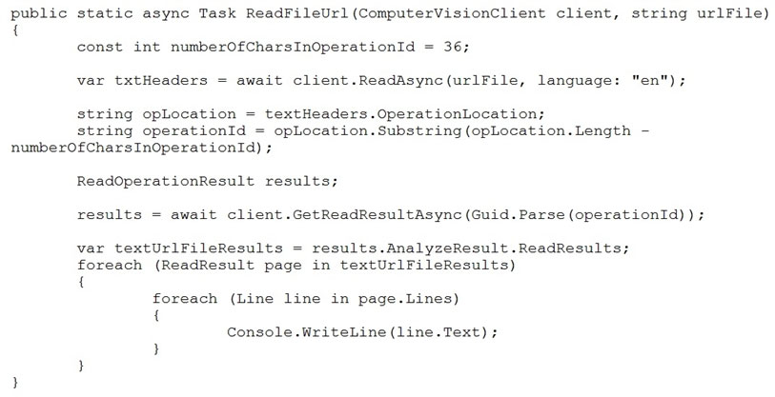  
During testing, you discover that the call to the GetReadResultAsync method occurs before the read operation is complete.  
You need to prevent the GetReadResultAsync method from proceeding until the read operation is complete.  
Which two actions should you perform? Each correct answer presents part of the solution.  
NOTE: Each correct selection is worth one point.

* **A.**Remove the Guid.Parse(operationId) parameter.
* **B.**Add code to verify the results.Status value.
* **C.**Add code to verify the status of the txtHeaders.Status value.
* **D.**Wrap the call to GetReadResultAsync within a loop that contains a delay.

Answer : **BD**

Example code :  
do  
{  
results = await client.GetReadResultAsync(Guid.Parse(operationId));  
}  
while ((results.Status == OperationStatusCodes.Running ||  
results.Status == OperationStatusCodes.NotStarted));  
Reference:  
https://github.com/Azure-Samples/cognitive-services-quickstart-code/blob/master/dotnet/ComputerVision/ComputerVisionQuickstart.cs

Next Question

##### **Question 12**

HOTSPOT -  
You have a Computer Vision resource named contoso1 that is hosted in the West US Azure region.  
You need to use contoso1 to make a different size of a product photo by using the smart cropping feature.  
How should you complete the API URL? To answer, select the appropriate options in the answer area.  
NOTE: Each correct selection is worth one point.  
Hot Area:  
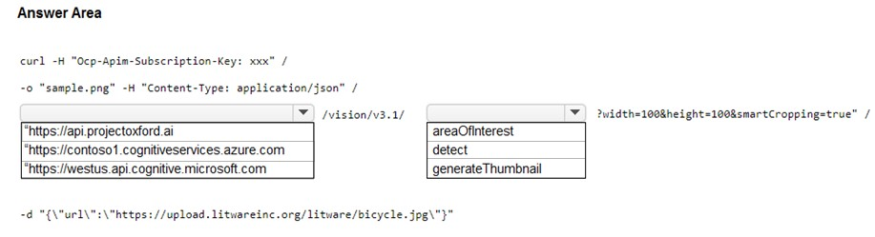

Answer : 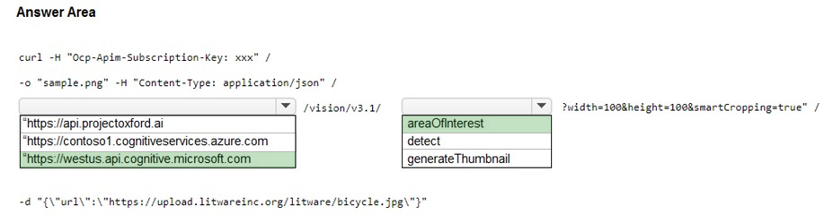

Reference:  
https://westus.dev.cognitive.microsoft.com/docs/services/computer-vision-v3-2/operations/56f91f2e778daf14a499f21b https://docs.microsoft.com/en-us/azure/cognitive-services/computer-vision/concept-generating-thumbnails#examples

Next Question

##### **Question 13**

DRAG DROP -  
You are developing a webpage that will use the Azure Video Analyzer for Media (previously Video Indexer) service to display videos of internal company meetings.  
You embed the Player widget and the Cognitive Insights widget into the page.  
You need to configure the widgets to meet the following requirements:  
✑ Ensure that users can search for keywords.  
✑ Display the names and faces of people in the video.  
✑ Show captions in the video in English (United States).  
How should you complete the URL for each widget? To answer, drag the appropriate values to the correct targets. Each value may be used once, more than once, or not at all. You may need to drag the split bar between panes or scroll to view content.  
NOTE: Each correct selection is worth one point.  
Select and Place:  
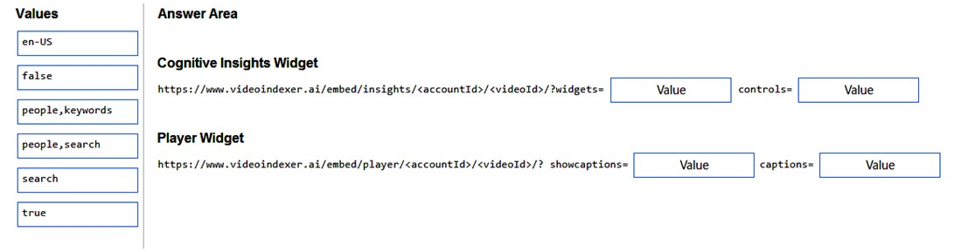

Answer : 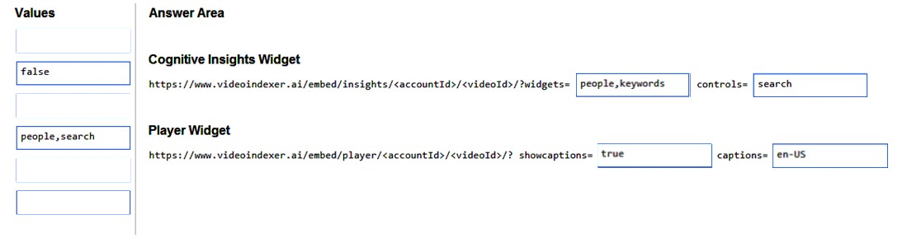

Reference:  
https://docs.microsoft.com/en-us/azure/azure-video-analyzer/video-analyzer-for-media-docs/video-indexer-embed-widgets

Next Question

##### **Question 14**

DRAG DROP -  
You train a Custom Vision model to identify a company's products by using the Retail domain.  
You plan to deploy the model as part of an app for Android phones.  
You need to prepare the model for deployment.  
Which three actions should you perform in sequence? To answer, move the appropriate actions from the list of actions to the answer area and arrange them in the correct order.  
Select and Place:  
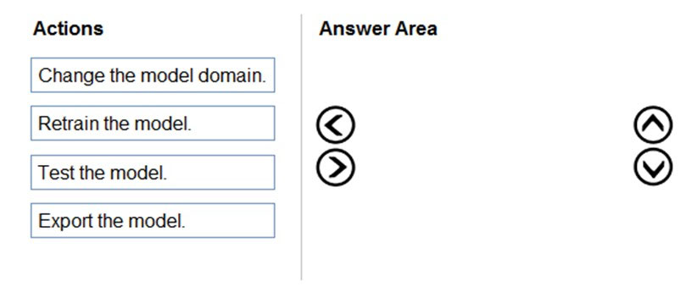

Answer : 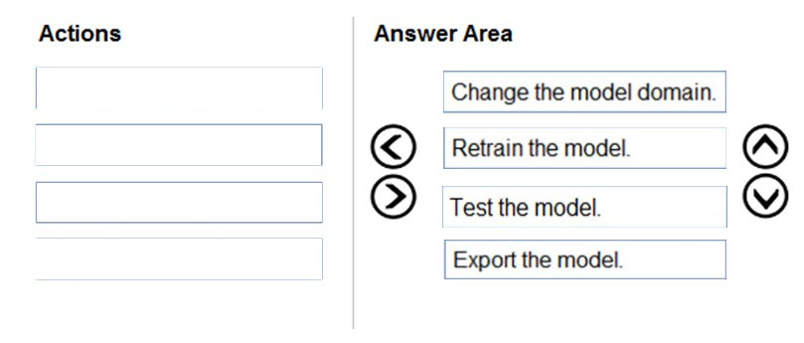

Reference:  
https://docs.microsoft.com/en-us/azure/cognitive-services/custom-vision-service/export-your-model

Next Question

##### **Question 15**

HOTSPOT -  
You are developing an application to recognize employees' faces by using the Face Recognition API. Images of the faces will be accessible from a URI endpoint.  
The application has the following code.  
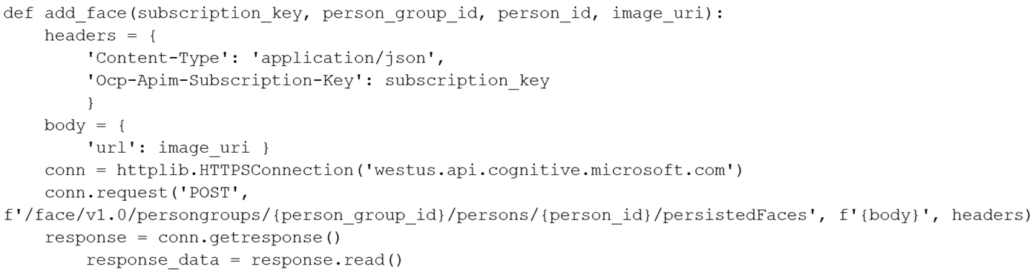  
For each of the following statements, select Yes if the statement is true. Otherwise, select No.  
NOTE: Each correct selection is worth one point.  
Hot Area:  
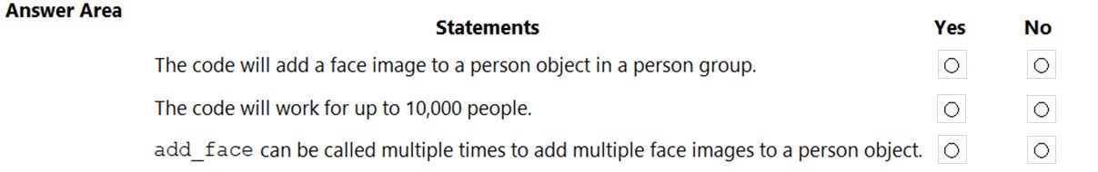

Answer : 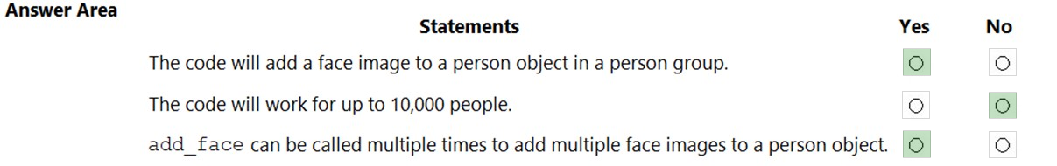

Reference:  
https://docs.microsoft.com/en-us/azure/cognitive-services/face/face-api-how-to-topics/use-persondirectory

### **Question 1**

Note: This question is part of a series of questions that present the same scenario. Each question in the series contains a unique solution that might meet the stated goals. Some question sets might have more than one correct solution, while others might not have a correct solution.

After you answer a question in this section, you will NOT be able to return to it. As a result, these questions will not appear in the review screen.

You have a chatbot that uses question answering in Azure Cognitive Service for Language

Users report that the responses of the chatbot lark formality when answering spurious questions

You need to ensure that the chatbot provides formal responses to spurious questions.

Solution: From Language Studio, you change the chitchat source to qna_chitchit_friindly.tsv. and then retrain and republish the model.

Does this meet the goal?

**A**Yes

**B**No

Expose Correct Answer

Answer : **B**

Next Question

### **Question 2**

Note: This question is part of a series of questions that present the same scenario. Each question in the series contains a unique solution that might meet the stated goals. Some question sets might have more than one correct solution, while others might not have a correct solution.

After you answer a question in this section, you will NOT be able to return to it. As a result, these questions will not appear in the review screen.

You have a chatbot that uses question answering in Azure Cognitive Service for Language

Users report that the responses of the chatbot lark formality when answering spurious questions

You need to ensure that the chatbot provides formal responses to spurious questions.

Solution: From Language Studio, you remove all the chit-chat question and answer pairs, and then retrain and republish the model

Does this meet the goal?

**A**Yes

**B**No

Expose Correct Answer

Answer : **B**

[Removing all the chit-chat question and answer pairs from the project will not ensure that the chatbot provides formal responses to spurious questions. It will only make the chatbot unable to handle any chit-chat scenarios, which may result in a poor user experience and a loss of engagement. Instead, you should choose a chit-chat personality that matches the tone and style of your chatbot, such as Professional or Caring.You can also edit the chit-chat questions and answers to suit your specific needs, or add new ones that are not in the predefined data set12. This way, you can ensure that the chatbot responds appropriately to spurious questions, while still maintaining a conversational and engaging interaction with the user.](https://learn.microsoft.com/en-us/azure/ai-services/qnamaker/how-to/chit-chat-knowledge-base)

Next Question

### **Question 3**

You have an Azure Cognitive Search solution and a collection of handwritten letters stored as JPEG files.

You plan to index the collection. The solution must ensure that queries can be performed on the contents of the letters.

You need to create an indexer that has a skillset.

Which skill should you include?

**A**key phrase extraction

**B**optical character recognition (OCR)

**C**document extraction

**D**image analysis

Expose Correct Answer

Answer : **B**

Next Question

### **Question 4**

You are developing a system that will monitor temperature data from a data stream. The system must generate an alert in response to atypical values. The solution must minimize development effort.

What should you include in the solution?

**A**Univariate Anomaly Detection

**B**Azure Stream Analytics

**C**metric alerts in Azure Monitor

**D**Multivariate Anomaly Detection

Expose Correct Answer

Answer : **D**

Next Question

### **Question 5**

Note: This question is part of a series of questions that present the same scenario. Each question in the series contains a unique solution that might meet the stated goals. Some question sets might have more than one correct solution, while others might not have a correct solution.

After you answer a question in this section, you will NOT be able to return to it. As a result, these questions will not appear in the review screen.

You are building a chatbot that will use question answering in Azure Cognitive Service for Language.

You have a PDF named Doc1.pdf that contains a product catalogue and a price list

You upload Doc1.pdf and train the model.

During testing, users report that the chatbot responds correctly to the following question: What is the price of ?

The chatbot fails to respond to the following question: How much does < product > cost?

You need to ensure that the chatbot responds correctly to both questions.

Solution: From Language Studio, you add alternative phrasing to the question and answer pair, and then retrain and republish the model.

Does this meet the goal?

**A**Yes

**B**No

Expose Correct Answer

Answer : **A**

<file:///C:/Users/DenilaRajendran/Downloads/AI-102-demo.pdf>

Question 1

You are building a chatbot for a travel agent. The chatbot will use the Azure OpenAI GPT 3.5 model and will be used to make travel reservations.

You need to maximize the accuracy of the responses from the chatbot.

What should you do?

**A**Configure the model to include data from the travel agent's database.

**B**Set the Top P parameter for the model to 0.

**C**Set the Temperature parameter for the model to 0.

**D**Modify the system message used by the model to specify that the answers must be accurate.

Reveal Answer

Answer : **A**

Next Question

Question 2

You have an Azure Cognitive Services model named Model that identifies the intent of text input.

You develop an app in C# named App1.

You need to configure App1 to use Model1.

Which package should you add to App1?

**A**Azure.AI.Language.Conversations

**B**SpeechServicesToolkit

**C**Universal.Microsoft.CognitiveServices.Speech

**D**Xamarin.Cognitive.Speech

Reveal Answer

Answer : **C**

Next Question

Question 3

You have an Azure subscription that contains an Azure App Service app named Appl.

You provision a multi-service Azure Cognitive Services resource named CSAccount1.

You need to configure App1 to access CSAccount1. The solution must minimize administrative effort.

What should you use to configure App1?

**A**a system-assigned managed identity and an X.509 certificate

**B**the endpoint URI and an OAuth token

**C**the endpoint URI and a shared access signature (SAS) token

**D**the endpoint URI and subscription key

Reveal Answer

Answer : **C**

Next Question

Question 4

You are developing an app that will use the Decision and Language APIs.

You need to provision resources for the app. The solution must ensure that each service is accessed by using a single endpoint and credential.

Which type of resource should you create?

**A**Language

**B**Speech

**C**Azure Cognitive Services

**D**Content Moderator

Reveal Answer

Answer : **C**

Next Question

Question 5

You are building a chatbot.

You need to ensure that the bot will recognize the names of your company's products and codenames. The solution must minimize development effort.

Which Azure Cognitive Service for Language service should you include in the solution?

**A**custom text classification

**B**entity linking

**C**custom Named Entity Recognition (NER)

**D**key phrase extraction

Reveal Answer

Answer : **C**

Next Question

Question 6

You are building an app that will include one million scanned magazine articles. Each article will be stored as an image file. You need to configure the app to extract text from the images. The solution must minimize development effort. What should you include in the solution?

**A**Computer Vision Image Analysis

**B**the Read API in Computer Vision

**C**Form Recognizer

**D**Azure Cognitive Service for Language

Reveal Answer

Answer : **B**

Next Question

Question 7

You are building a Chatbot by using the Microsoft Bot Framework SDK. The bot will be used to accept food orders from customers and allow the customers to customize each food item. You need to configure the bot to ask the user for additional input based on the type of item ordered. The solution must minimize development effort. Which two types of dialogs should you use? Each correct answer presents part of the solution. NOTE: Each correct selection is worth one point.

**A**adaptive

**B**action

**C**waterfall

**D**prompt

**E**input

Reveal Answer

Answer : **B, C**

<file:///C:/Users/DenilaRajendran/Downloads/AI-102-demo%20(1).pdf>

